
CSE400B Capstone Project Report

PhishGuard - A Multi-Model Phishing Detection System with Anomaly-Based Intelligence for Web and Text Threats

Student Information
Name : Jannatul Ferdaus Oishi
Id: 2022-3-60-216

Name: MD Arham Jawad Akib
Id: 2022-3-60-004

Name: Mahin Ahmed Meghla
Id: 2022-3-60-152

Name: Md. Maruf Ahmed Anik
Id: 2022-3-60-040

Supervisor
Dr. Sarwar Jahan
Associate Professor

Department of Computer Science & Engineering

Contents
Abstract______________________________________________________________________4
1. Introduction________________________________________________________________5
1.1 Background_____________________________________________________________5
1.2 Cybersecurity Threat Landscape_____________________________________________5
1.3 Phishing Attacks and Their Impact___________________________________________6
2.RelatedWork________________________________________________________________6
2.1 Existing Phishing Detection Systems: Global Approaches and Limitations____________6
2.2 Academic Research in Phishing Detection_____________________________________6
2.3 Browser-Based Phishing Detection__________________________________________ 7
2.4 Feature Engineering for Phishing Detection___________________________________ 7
2.5 Brand Similarity and Typosquatting Detection_________________________________ 7
2.6 Threat Intelligence Integration______________________________________________7
2.7 Comparative Analysis: Existing Solutions vs PhishGuard Lite_______________________8
2.8 Research Gaps Identified and Addressed by PhishGuard Lite______________________9
3. Dataset Description__________________________________________________________9
3.1 Data Collection Methodology_______________________________________________9
3.2 Dataset Composition_____________________________________________________10
3.3 Data Cleaning and Preprocessing___________________________________________10
3.4 Dataset Balancing_______________________________________________________11
3.5 Feature Engineering_____________________________________________________11
3.6 Train / Test Split and Final Feature Matrix____________________________________11
4. Methodology_______________________________________________________________13
4.1 System Architecture Overview_____________________________________________13
4.2 URL Feature Extraction and Classification_____________________________________14
4.3 Risk Score Calculation and Alert Thresholds___________________________________15
4.4 Multi-Stage Threat Intelligence and Infrastructure Correlation____________________15
4.5 Browser Extension Integration_____________________________________________16
5. Research Questions and Objectives_____________________________________________18
5.1 Research Questions______________________________________________________18
5.2 Research Objectives_____________________________________________________18
6. Experimental Results and Performance Analysis__________________________________19
6.1 Evaluation Protocol and Metrics____________________________________________19
6.2 XGBoost Classifier Performance____________________________________________19
6.3 Isolation Forest Anomaly Detector Performance_______________________________19
6.4 ROC Curve Comparison___________________________________________________21
6.5 Decision Fusion and Alert-Threshold Calibration_______________________________21
6.6 Discussion of Results_____________________________________________________22
7. Discussion, Limitations, and Future Work________________________________________23
7.1 Discussion of System Performance__________________________________________23
7.2 Study Limitations________________________________________________________23
7.3 Future Work and Research Directions________________________________________23
8. Conclusion_________________________________________________________________24
References___________________________________________________________________25

Abstract
Phishing remains one of the most widespread and financially damaging forms of cybercrime, targeting individuals and organizations by exploiting human trust to steal sensitive information such as login credentials, financial data, and personal information. As phishing attacks continue to evolve, attackers increasingly rely on newly registered or short-lived domains, making them difficult to detect using conventional blacklist-based security mechanisms. Widely used solutions, including Google Safe Browsing and Microsoft SmartScreen, provide effective protection against previously identified phishing websites but often fail to recognize zero-day attacks or newly emerging malicious domains before they are reported and added to their databases.
To address these limitations, this report presents PhishGuard Lite, a lightweight and real-time phishing detection system designed for browser-based protection. The proposed system consists of three tightly integrated components: a machine-learning-based URL scoring engine, a FastAPI-powered threat-intelligence backend, and a Google Chrome extension developed using Manifest V3. Together, these components enable rapid phishing detection while maintaining low computational overhead, making the system suitable for real-time deployment in modern web browsers.
The URL scoring engine combines both supervised and anomaly-based machine learning techniques to improve detection performance. Each URL is represented using a 3,000-dimensional character-level TF-IDF feature vector along with 32 handcrafted lexical, structural, statistical, and brand-similarity features that capture important characteristics commonly associated with phishing URLs. These features are used to train two complementary models: an XGBoost supervised classifier, which learns to distinguish legitimate and phishing URLs from labeled data, and an Isolation Forest anomaly detector trained exclusively on legitimate URLs to identify suspicious patterns that may indicate previously unseen phishing attacks.
The proposed models were evaluated using a cleaned and balanced dataset containing 300,000 URLs. On a held-out test set of 62,474 URLs, the XGBoost classifier achieved an accuracy of 91.3% with a ROC-AUC score of 0.970, demonstrating strong classification performance. The Isolation Forest anomaly detector achieved a ROC-AUC score of 0.723 and successfully identified 91.7% of genuinely malicious URLs within the top 5% most anomalous predictions, highlighting its effectiveness in detecting potential zero-day phishing attacks.
To improve overall detection reliability, the outputs of both machine learning models are combined using a weighted decision-fusion strategy, assigning 70% weight to the supervised classifier and 30% weight to the anomaly detector, while also incorporating a confidence bonus from Google Safe Browsing whenever applicable. Based on the final confidence score, the system generates an intuitive three-tier alert mechanism consisting of GREEN, YELLOW, and RED risk levels. Experimental evaluation shows that this hybrid approach detects 91.1% of phishing URLs at a 12.0% false-positive rate, while the stricter RED alert tier detects 84.9% of phishing attacks with only a 3.0% false-positive rate, providing users with flexible security thresholds depending on their desired level of protection.
Beyond URL classification, PhishGuard Lite performs comprehensive threat-intelligence analysis to investigate the infrastructure associated with suspicious domains. The FastAPI backend conducts multiple stages of open-source intelligence (OSINT), including certificate transparency log searches, reverse-IP host discovery, subdomain enumeration, favicon hashing, and HTML/JavaScript fingerprinting. These techniques enable the system to correlate suspicious websites with related phishing-kit infrastructure, uncover malicious domain relationships, and provide valuable contextual information for security analysts.
Overall, the results demonstrate that PhishGuard Lite provides an effective and practical solution for modern phishing detection. By combining supervised learning, anomaly detection, threat-intelligence analysis, and browser integration into a lightweight architecture, the system significantly improves the detection of both known and previously unseen phishing attacks compared to traditional blacklist-only approaches. At the same time, its efficient design ensures that phishing analysis can be performed quickly enough to provide real-time protection without compromising the browsing experience.

Keywords:: Phishing Detection, Machine Learning, XGBoost, Isolation Forest, URL Classification, TF-IDF, Threat Intelligence, Open-Source Intelligence (OSINT), FastAPI, Chrome Manifest V3, Real-Time Detection, Zero-Day Phishing Detection.

1. Introduction

1.1 Background
The rapid growth of the Internet has transformed communication, education, business, banking, and government services, making web-based applications essential to daily life. This digital transformation has also expanded the attack surface available to cybercriminals, with phishing standing out as one of the most common and financially damaging threats facing individuals and organizations alike.
Phishing is a social-engineering attack in which an adversary creates fake websites, emails, or messages that imitate legitimate organizations in order to steal sensitive information such as usernames, passwords, banking details, and personal data. Modern phishing campaigns rely on techniques such as domain spoofing, URL obfuscation, homograph (look-alike Unicode) attacks, typosquatting, URL shortening, and the abuse of free SSL certificates to appear trustworthy and evade traditional security controls.
Traditional blacklist-based detection systems are often ineffective against newly created phishing websites because they can only flag URLs that have already been reported and verified. Machine learning offers a more resilient alternative by analyzing the lexical, structural, and statistical properties of a URL to detect both previously seen and never-before-seen phishing attempts without depending solely on blacklists.
To address these challenges, this project develops PhishGuard Lite, a system that combines supervised learning (XGBoost), unsupervised anomaly detection (Isolation Forest), handcrafted URL feature extraction, character-level TF-IDF analysis, Google Safe Browsing verification, WHOIS domain-age analysis, and RapidFuzz-based brand-similarity detection. This hybrid approach is designed to deliver fast, lightweight, and accurate real-time phishing detection directly inside the user's browser, protecting against both known and zero-day phishing attacks.

1.2 Cybersecurity Threat Landscape
Cybersecurity has become a critical concern as the rapid growth of digital services has increased exposure to threats such as malware, ransomware, phishing, credential theft, identity fraud, and financial scams. Among these, phishing remains one of the most common attack vectors because it exploits human trust rather than purely technical vulnerabilities, impersonating banks, government agencies, e-commerce platforms, and cloud providers to harvest sensitive information.
Modern phishing operations increasingly use automation to generate convincing, short-lived pages: homograph domains, typosquatted brand names, URL shorteners, and compromised legitimate hosting to slip past conventional filters. Because blacklist-based systems rely on manually curated and periodically updated signature databases, users typically remain exposed until a malicious URL has already been reported, verified, and propagated to the blacklist, a window during which the majority of damage from a phishing campaign is done.

1.3 Phishing Attacks and Their Impact
Phishing affects millions of users every year across financial institutions, e-commerce platforms, educational organizations, healthcare providers, and government services. Successful attacks can lead to direct financial losses, identity theft, unauthorized account access, data breaches, ransomware infections, and lasting reputational damage to the impersonated brand.
The growth of online banking, digital payments, and cloud-based services has amplified the financial stakes: attackers replicate login pages with near-pixel accuracy, tricking users into entering credentials or payment information. Techniques such as URL shortening, domain typosquatting, homograph substitution, HTTPS abuse through free certificate authorities, brand impersonation, and rapidly rotated, newly registered domains all reduce the effectiveness of conventional blacklist-based detection motivating the intelligent, feature-driven detection approach developed in this project.

1.3.1 Research Objectives

Objective 1: Build a Lightweight, Real-Time Phishing Detection Tool
Build a phishing detection system made up of a Chrome browser extension (using Manifest V3) and a FastAPI backend working together. The tool should check URLs as someone browses the web, give a quick risk result, and do this without slowing down the browser or using heavy processing on the user's device.

Objective 2: Improve Detection Accuracy with a Hybrid Machine Learning Model
Build and test a phishing detection model that combines two things: a TF-IDF representation of the URL text (3,000 features) and 32 handcrafted features that describe the URL's structure, patterns, and similarity to known brands. Use XGBoost to classify known types of phishing, and Isolation Forest to catch new, never-seen-before phishing attempts. Together, these should make the detection more accurate and better at handling attacks the model hasn't seen during training.

Objective 3: Improve Reliability with Threat Intelligence from Multiple Sources
Make phishing detection more reliable by pulling in extra information from outside sources — Google Safe Browsing, VirusTotal, WHOIS records, certificate transparency logs, reverse-IP lookups, subdomain discovery, favicon hashing, and HTML structure comparison. Combine this infrastructure-level evidence with the machine learning result to give a human reviewer a fuller picture — showing things like linked domains, shared hosting or certificates, and matching phishing-kit fingerprints — so they can make a better-informed decision about a suspicious website, beyond just the URL itself.

1.3.2 Research Questions
Main Research Question:
Can a single phishing detection tool manage to be quick enough for everyday browsing, while also giving investigators the detailed evidence they need to dig deeper — by pairing fast machine learning predictions with real, external threat data?
To explore this, the study looks at three smaller questions:
RQ1: Can a browser extension check a URL fast enough — within just a couple of seconds — to warn someone about a phishing site without making their browsing feel slow?
RQ2: Does pairing a supervised model (XGBoost) with an anomaly detector (Isolation Forest) really catch more phishing sites — both familiar ones and completely new ones the model has never seen — than using just one of them alone, or than other machine learning models tested along the way?
RQ3: Looking past the URL itself, how much useful extra detail — things like WHOIS records, shared hosting, matching certificates, or similar phishing-kit patterns — can be pulled from outside sources to help someone actually understand and investigate a suspicious website?

2. Literature Review

2.1 Existing Phishing Detection Systems: Global Approaches and Limitations

2.1.1 Commercial Browser Protection Systems
Google Safe Browsing is one of the most widely deployed blacklist-based phishing and malware protection systems, integrated into Chrome, Firefox, and Safari. It maintains a continuously updated database of malicious URLs and compares visited pages against known threats using cloud-based hash matching.
Advantages: extremely fast lookup, large-scale deployment, low computational overhead.
Limitations: detects only previously identified threats, limited capability against zero-day phishing, requires continuous connectivity, and performs no independent ML-based URL analysis.
Microsoft Defender SmartScreen provides phishing and malicious-site detection through reputation scoring, certificate verification, and cloud threat intelligence. It offers high accuracy for known threats but, like Safe Browsing, depends heavily on historical reputation and is largely ineffective against freshly registered domains.
Popular anti-phishing browser extensions Netcraft, McAfee WebAdvisor, Norton Safe Web, and Avast Online Security rely primarily on blacklist and reputation databases. Their common weaknesses are vendor dependency, limited transparency, absence of anomaly detection, poor adaptability to emerging phishing patterns, and, in several cases, subscription costs.

2.2 Academic Research in Phishing Detection

2.2.1 Traditional URL-Based Detection
Early phishing detection relied on blacklists, whitelists, and rule-based heuristics using simple features such as URL length, dot count, suspicious keywords, and special characters. These approaches suffer from high maintenance cost, poor scalability, inability to detect zero-day attacks, and vulnerability to trivial URL obfuscation.

2.2.2 Machine Learning-Based Phishing Detection
Recent studies employ classifiers such as Decision Trees, Random Forests, Support Vector Machines, Logistic Regression, and Gradient-Boosted Trees on handcrafted URL features. Sahingoz et al. [1] were among the first to demonstrate that NLP-based and word-vector features combined with classical classifiers could detect phishing URLs without relying on third-party services, reporting accuracies above 97%. Aljofey et al. [5] combined character-level features with XGBoost and reported strong generalization across multiple phishing datasets, while Feng et al. [6] extended this to combined URL-and-HTML feature sets. More recent work has validated XGBoost specifically for this task: cross-dataset validation studies [7] confirm that XGBoost-based models retain accuracy when tested on previously unseen phishing datasets, Umamageswari et al. [8] paired XGBoost with the Google Safe Browsing API for real-time verification, Keerthana et al. [9] benchmarked Decision Tree, Random Forest, and XGBoost together and found XGBoost consistently superior, and Ahmed et al. [10] reported similar findings using comprehensive feature extraction on a regional (Bangladesh-focused) dataset. Across this body of work, reported limitations include heavy dependence on training-data quality, limited explainability, and difficulty generalizing to previously unseen obfuscation techniques — motivations directly reflected in this project's use of a combined supervised and anomaly-based architecture, and its explicit multi-model comparison in Section 5.4.1.
Table 2.2.1 summarizes the fifteen most directly relevant peer-reviewed and preprint studies on machine-learning- and deep-learning-based phishing URL detection reviewed for this project, organized by method and mapped to their key contribution and limitation.

Table 2.2.1: Summary of Reviewed Literature on ML- and DL-Based Phishing Detection
No. | Authors & Year | Method / Approach | Key Contribution | Limitation
1 | Sahingoz et al. (2019) [1] | NLP/word-vector features + classical ML classifiers | Detects phishing without relying on third-party services; >97% accuracy | Not evaluated against modern obfuscation/typosquatting
2 | Aljofey et al. (2023) [5] | Character-level features + XGBoost | Strong cross-dataset generalization | Limited handling of infrastructure-level context
3 | Feng et al. (2022) [6] | Combined URL + HTML features | Improves detection using page content, not just URL string | Requires live page fetch; unsuitable for pre-navigation blocking
4 | Cross-Dataset XGBoost Study (2025–2026) [7] | XGBoost with cross-dataset validation | Confirms XGBoost robustness across differing phishing datasets | Single-model evaluation; no anomaly/zero-day component
5 | Umamageswari et al. (2025) [8] | XGBoost + Google Safe Browsing API | Combines ML prediction with external blacklist verification | No infrastructure correlation or campaign-level analysis
6 | Keerthana et al. (2025) [9] | Decision Tree, Random Forest, XGBoost comparison | Empirically confirms XGBoost superiority among tree-based models | Comparison limited to tree-based supervised models only
7 | Ahmed et al. (2024) [10] | Comprehensive feature extraction + ML (Bangladesh dataset) | Validates ML phishing detection on a regional dataset | Regional dataset limits generalizability
8 | Odeh et al. (2023) [27] | CatBoost vs XGBoost vs LightGBM comparison | Direct performance benchmarking across three boosting algorithms | No anomaly detection or hybrid architecture
9 | Jovanovic et al. (2023) [28] | Hybrid two-level feature selection + XGBoost tuning | Improves detection via automated hyperparameter tuning | Added tuning complexity; no real-time browser deployment
10 | Kustiawan & Ghauth (2025) [29] | Systematic review of feature engineering for phishing detection | Surveys and categorizes feature types across the literature | Review only; proposes no new model
11 | Islam et al. (2024) [30] | CNN-based phishing URL detection with explainability | Deep-learning approach with interpretable outputs | Higher compute cost, less suited to lightweight in-browser use
12 | Koide et al. (2024) [31] | LLM-based phishing site detection (ChatPhishDetector) | Uses large language models to reason about page content | High latency and API cost unsuitable for real-time blocking
13 | Liu et al. (2024) [32] | Reference-based detection without a pre-defined reference list | Removes dependency on static brand/reference lists | Still requires page content/screenshot analysis
14 | Liu et al. (2024) [33] | TransURL — multi-layer transformer encoding | Improves detection via transformer-based URL encoding | Significant computational overhead vs. classical ML
15 | Malicious URL Detection Survey (2025) [34] | Survey of malicious URL detection techniques, datasets, and code | Broad comparative overview of the field | Survey only; no original detection system proposed
Across the fifteen reviewed studies, three consistent patterns emerge. First, XGBoost and other gradient-boosting variants dominate the recent supervised-learning literature on phishing URL detection [1, 5, 7, 8, 9, 10, 27, 28], consistently outperforming simpler classifiers while remaining lightweight enough for real-time inference — directly motivating its selection as the supervised component of PhishGuard Lite. Second, no reviewed study combines a supervised classifier with an unsupervised anomaly detector for zero-day coverage; each system is either purely supervised or purely deep-learning-based, leaving unseen-attack detection largely unaddressed outside of the anomaly-detection literature discussed separately in Section 2.6. Third, deep-learning and LLM-based approaches [30, 31, 33] report strong accuracy but consistently note higher computational cost and latency, reinforcing the decision to use a compact classical pipeline for in-browser deployment rather than a neural model.

2.2.3 Deep Learning-Based Detection
CNN, LSTM, Bi-LSTM, and Transformer/BERT-based models learn patterns directly from raw URL text, reducing manual feature engineering, but at the cost of higher computational load, larger memory footprint, and reduced suitability for lightweight, in-browser deployment a key reason this project favors a compact XGBoost + Isolation Forest pipeline over a deep neural model.

2.3 Browser-Based Phishing Detection
Several studies propose browser extensions that combine machine learning with real-time page analysis, typically following the architecture Browser → Extension → Backend Server → ML Model → Warning Page. Reported limitations include reliance on a single classifier, absence of anomaly detection, limited external verification, and poor scalability gaps that PhishGuard Lite directly targets through its hybrid model and multi-stage infrastructure investigation.

2.4 Feature Engineering for Phishing Detection
Feature engineering significantly improves phishing detection accuracy. Common categories include lexical features (URL/host length, character composition), structural features (subdomain count, path depth, query length), statistical features (entropy, digit ratio), and security features (HTTPS usage, WHOIS data, SSL certificate properties). Prior work frequently uses fewer than 15 features and offers weak support for brand impersonation or typosquatting PhishGuard Lite extends this to 32 handcrafted features plus a 3,000-dimensional TF-IDF character representation.

2.5 Brand Similarity and Typosquatting Detection
Phishing pages frequently imitate trusted brands such as Google, PayPal, Microsoft, Amazon, and Facebook. Techniques such as Levenshtein distance, fuzzy string matching (RapidFuzz), and domain-similarity analysis are used to flag typosquatted or homograph-substituted domains, though most systems remain dependent on a predefined brand list and struggle with previously unseen brands.
The brand_spoof_score uses RapidFuzz fuzz.ratio which computes normalized Indel similarity:
Similarity(a, b) = 100 x (1 - Indel(a, b) / (|a| + |b|))
where Indel(a, b) is the insertion-deletion distance, |a| and |b| are string lengths. Score 100 = exact match

2.6 Threat Intelligence Integration
Several frameworks incorporate external intelligence sources such as Google Safe Browsing, VirusTotal, OpenPhish, PhishTank, and URLHaus for real-time verification. These sources add valuable corroborating signals but introduce API rate limits, network latency, and like all blacklists limited zero-day coverage.

2.7 Comparative Analysis: Existing Solutions vs PhishGuard Lite
Table 2.7.1 compares PhishGuard Lite with existing phishing detection solutions based on detection approach, zero-day detection, threat intelligence, and deployment. It highlights the advantages of the proposed hybrid machine learning framework for accurate, real-time phishing detection.
Table 2.7.1: Comparison of Existing Phishing Detection Solutions and PhishGuard Lite

Aspect | Google Safe Browsing | MS SmartScreen | Netcraft / WebAdvisor | PhishGuard Lite (Proposed)
Detection basis | Blacklist / hash match | Reputation score | Blacklist + reputation | ML (XGBoost + Isolation Forest) + TF-IDF + OSINT
Zero-day coverage | Low | Low | Low | High anomaly detector flags unseen URLs
Feature-based analysis | No | Partial | No | Yes, 32 handcrafted + 3,000 TF-IDF features
Brand / typosquat detection | No | Limited | Limited | Yes, RapidFuzz similarity vs Tranco brands
Infrastructure correlation | No | No | No | Yes, cert-transparency, reverse-IP, subdomain, favicon/HTML fingerprinting
Deployment footprint | Built into browser | Built into OS/browser | Extension + cloud | Lightweight Chrome extension + FastAPI backend
Transparency / customizability | Closed | Closed | Closed | Open, modular, retrainable pipeline
Reported AUC on held-out test set | N/A (blacklist) | N/A | N/A | 0.970 (XGBoost)

Key Advantages of PhishGuard Lite
The proposed PhishGuard Lite framework incorporates several design features that enhance its effectiveness, efficiency, and suitability for real-time phishing detection. These advantages distinguish the framework from traditional URL-based detection approaches by combining multiple complementary techniques within a unified architecture.

Hybrid Detection Framework
- PhishGuard Lite combines supervised classification and unsupervised anomaly detection to improve overall detection performance. While the XGBoost classifier accurately identifies known phishing patterns learned from labeled data, the Isolation Forest detects anomalous URL characteristics that may indicate previously unseen or zero-day phishing attacks. This complementary design improves the framework's robustness against evolving phishing techniques.

Comprehensive Feature Representation
- The detection framework utilizes a rich feature representation by combining 32 handcrafted URL features with 3,000 character-level TF-IDF features. The handcrafted features capture lexical, structural, statistical, and brand-related characteristics, while the TF-IDF representation identifies subtle textual patterns such as typosquatting, brand impersonation, and URL obfuscation. Together, these features provide a comprehensive description of each URL, enabling accurate machine learning-based classification.

Multi-Layer Threat Verification
- To improve the reliability of prediction results, machine learning outputs are complemented with external threat intelligence. The framework integrates Google Safe Browsing and VirusTotal verification, allowing suspicious URLs to be validated using trusted security intelligence rather than relying solely on machine learning predictions. This multi-layer verification process reduces uncertainty and strengthens confidence in the final classification.

Infrastructure Correlation Analysis
- Beyond URL classification, PhishGuard Lite performs infrastructure-based analysis to identify relationships between suspicious websites. By incorporating certificate transparency logs, reverse-IP analysis, subdomain enumeration, favicon hashing, and HTML/JavaScript fingerprinting, the framework can associate related phishing websites that share common infrastructure or phishing kits. This additional context supports more comprehensive phishing investigations and improves the identification of coordinated phishing campaigns.

Lightweight Real-Time Deployment
- The framework is designed for efficient real-time operation through a Chrome Manifest V3 extension integrated with a FastAPI backend. Computationally intensive tasks are performed on the backend, allowing the browser extension to remain lightweight while providing rapid phishing detection with minimal impact on the user's browsing experience. This architecture makes the system practical for deployment in everyday web browsing environments.

2.8 Research Gaps Identified and Addressed by PhishGuard Lite

Gap 1: Dependence on Blacklists
Current state: commercial solutions primarily rely on blacklists. Research gap: blacklists cannot detect newly created phishing websites. PhishGuard Lite's solution: hybrid detection using XGBoost and Isolation Forest, so previously unseen URLs still receive a risk score.

Gap 2: Lack of Anomaly Detection
Current state: most browser extensions use only supervised learning. Research gap: unseen phishing attacks remain difficult to identify without labelled examples. PhishGuard Lite's solution: an Isolation Forest trained exclusively on legitimate URLs flags structurally anomalous URLs regardless of whether similar phishing examples exist in the training set.

Gap 3: Weak Brand-Impersonation Detection
Current state: most systems ignore typosquatting. Research gap: brand spoofing remains under-explored. PhishGuard Lite's solution: RapidFuzz-based brand-similarity scoring against Tranco top-ranked domains.

Gap 4: Limited Multi-Layer Verification
Current state: existing approaches depend on a single detection mechanism. Research gap: lack of integrated threat intelligence. PhishGuard Lite's solution: Google Safe Browsing, WHOIS, VirusTotal, and infrastructure-correlation modules feed into a single fused decision.

Gap 5: Lightweight Real-Time Browser Protection
Current state: deep-learning approaches require significant computational resources. Research gap: few lightweight systems support in-browser deployment. PhishGuard Lite's solution: a Chrome Extension (Manifest V3) paired with a FastAPI backend and an optimized, classical ML pipeline that predicts in milliseconds per URL.

3. Dataset Description

3.1 Data Collection Methodology
A high-quality and diverse dataset is essential for developing a phishing detection model capable of generalizing to real-world attacks. Rather than relying on a single source, PhishGuard Lite combines multiple publicly available phishing URL datasets with a trusted-domain repository to capture a wide variety of legitimate and malicious URL patterns. Using data from multiple sources reduces dataset bias, improves feature diversity, and enables the model to learn phishing techniques originating from different campaigns and time periods.
The training dataset was constructed from the following publicly available sources:
- Phishing Site URLs Dataset (phishing_site_urls.csv) – This dataset contains 549,346 labeled URLs collected from historical phishing campaigns and legitimate websites. It provides a large collection of real phishing URLs exhibiting diverse lexical patterns, making it one of the primary sources for supervised model training.

- Malicious URLs Dataset (malicious_phish.csv) – Consisting of 651,346 URLs, this dataset includes four categories: phishing, malware, defacement, and benign. For this research, the three malicious categories were consolidated into a single malicious class, enabling the development of a binary phishing detection model while preserving a broad range of malicious URL characteristics. A binary formulation was deliberately chosen over the dataset's native four-class scheme because PhishGuard Lite's operational goal is a real-time allow/block decision at the browser level, not malware-family attribution; collapsing malware and defacement into the malicious class lets the model still learn from their structural URL patterns while keeping the output directly actionable as a single phishing risk score.
- PhiUSIIL Phishing URL Dataset – This peer-reviewed research dataset contains 235,795 labeled URLs and has been widely used in phishing detection studies. Since its labeling convention differs from the other datasets, the labels were normalized during preprocessing to maintain consistency across the combined dataset.

- Malicious URL v3 Dataset – This supplementary dataset contains 49,750 phishing and legitimate URLs. Although smaller in size, it contributes additional URL variations and helps improve the diversity and robustness of the training data.
In addition to the labeled datasets, the Tranco Top Sites list (tranco_43Z8X.csv) containing the top 100,000 globally ranked websites was incorporated into the framework. The Tranco dataset serves two important purposes. First, it provides a reliable source of trusted domains for the legitimate class, reducing the likelihood of training on outdated or suspicious websites. Second, it acts as the reference repository for RapidFuzz-based brand similarity analysis, allowing the system to detect phishing URLs that imitate popular brands through typosquatting, misspellings, or visually similar domain names.
By integrating multiple phishing datasets with a trusted-domain repository, the final dataset captures a broad spectrum of legitimate websites, known phishing campaigns, and malicious URL structures. This diverse data foundation improves the model's ability to generalize to previously unseen phishing attacks while reducing dependence on the characteristics of any single dataset.

3.2 Dataset Composition
The four labelled CSV sources alone contributed 1,486,082 raw rows. To correct a systematic bias in the raw phishing datasets which contain almost no legitimate 'www.' subdomain variants the Tranco apex domains were programmatically expanded into apex, apex+slash, www-prefixed, and www+slash variants, along with a 32,000-row "top-brand boost" set covering common paths (/, /home, /login, /about, ...) for the 2,000 highest-ranked Tranco domains. Without this augmentation, the model learns to associate the mere presence of 'www.' with legitimacy and produces false positives on ordinary sites.
Table 3.2.1: Summary of URL Datasets Used for Model Development
Source | Raw Rows | Legitimate | Phishing
phishing_site_urls.csv | 549,346 | 392,924 | 156,422
malicious_phish.csv | 651,191 | 428,103 | 223,088
PhiUSIIL_Phishing_URL_Dataset.csv | 235,795 | 134,850 | 100,945
Malicious URL v3.csv | 49,750 | 36,419 | 13,331
Tranco (apex + slash + www variants + top-brand boost) | 219,500 | 219,500 | 0
Table 3.2.1 summarizes the datasets used in this study, including their sources, total number of URLs, and the distribution of legitimate and phishing samples used for model development and evaluation.

3.3 Data Cleaning and Preprocessing
Since the datasets originated from independent repositories, a multi-step cleaning pipeline was applied before feature extraction:
- Normalization — URLs lower-cased, stripped of leading/trailing whitespace, and reduced to a consistent form.
- Basic validity filtering — empty strings and URLs shorter than 4 characters discarded.
- Label-conflict resolution — URLs that appear in more than one source with contradictory labels are removed entirely rather than arbitrarily resolved, to avoid injecting label noise (96,185 conflicting URLs removed).
- Duplicate removal — exact duplicate URLs collapsed to a single row (458,532 duplicates removed).
- Host extraction — the registrable host is parsed from every URL for downstream grouping and feature extraction; rows with an unparsable host are dropped.
After the full pipeline, the combined, de-duplicated, conflict-free dataset contained 1,050,117 URLs across 481,515 unique hosts, distributed as 724,748 legitimate and 325,369 phishing URLs.

3.4 Dataset Balancing
Following data cleaning and preprocessing, the combined dataset exhibited an imbalance between legitimate and phishing URLs. Training a machine learning model on such an imbalanced dataset can bias the classifier toward the majority class, resulting in high overall accuracy but poor detection of phishing websites. Since phishing detection is a security-critical task, correctly identifying malicious URLs is more important than simply maximizing classification accuracy.
To address this issue, a balanced dataset was created by randomly selecting 150,000 legitimate URLs and 150,000 phishing URLs, resulting in a final dataset of 300,000 samples. Random sampling was performed after preprocessing to ensure that each class retained a diverse representation of URL structures and phishing patterns. The selected samples were then thoroughly shuffled before being divided into training and testing sets, preventing any ordering bias during model learning.
Using an equal number of samples from both classes enables the classifier to learn decision boundaries without favoring the majority class. This balanced sampling strategy improves the model's ability to recognize phishing URLs, increases recall for the malicious class, and reduces the likelihood that tree-based algorithms, such as XGBoost, will disproportionately predict the legitimate class. Consequently, the resulting model provides a more reliable and balanced performance for real-world phishing detection, where accurately identifying malicious websites is critical for user protection.

3.5 Feature Engineering

3.5.1 TF-IDF Character-Level Features
To capture the textual characteristics of URLs, PhishGuard Lite employs a Term Frequency–Inverse Document Frequency (TF-IDF) vectorizer at the character level. Unlike word-based tokenization, character-level analysis is more suitable for phishing URL detection because malicious URLs often contain misspellings, typosquatting patterns, inserted symbols, random character sequences, or slight modifications of well-known brand names that may not form valid words. Character n-grams enable the model to identify these subtle lexical patterns while remaining robust to variations in URL structure.
The TF-IDF vectorizer was configured using the char_wb analyzer with an n-gram range of 3–5 and a minimum document frequency (min_df) of 5. This configuration extracts contiguous sequences of three to five characters that frequently occur across the training dataset while filtering out extremely rare patterns that contribute little to classification performance. The vectorizer was fitted exclusively on the training dataset to prevent data leakage and ensure that information from the test set did not influence feature generation or model training.
After training, the vectorizer generated a sparse feature matrix containing 3,000 character-level TF-IDF features for each URL. These features capture recurring lexical patterns commonly associated with phishing websites, including suspicious keywords, fragments of popular brand names, unusual character combinations, domain obfuscation techniques, repeated symbols, and encoded or randomized strings. By representing URLs as weighted numerical vectors, the TF-IDF transformation enables the classifier to distinguish between legitimate and malicious URLs based on subtle textual similarities and differences that are often difficult to detect using handcrafted rules alone.
The resulting TF-IDF representation forms the primary textual feature set of the proposed framework and is subsequently combined with handcrafted URL-based features to provide a comprehensive description of each URL before classification.
Formally, the TF-IDF weight for character n-gram t in URL d within corpus D:
TF(t, d) = f(t, d) / Sum f(t_prime, d)
Since scikit-learn uses smooth_idf=True by default, the IDF formula includes additive smoothing:
IDF(t, D) = log( (1 + |D|) / (1 + df(t)) ) + 1
where |D| is the corpus size and df(t) is the document frequency. Combined:
TF-IDF(t, d, D) = TF(t, d) x IDF(t, D)
After computing TF-IDF values, L2 normalization is applied so each URL vector has unit Euclidean length .

3.5.2 Handcrafted URL Features

In addition to TF-IDF, 32 handcrafted features were extracted per URL to capture lexical, structural, statistical, security, and brand-similarity signals:

Table 3.5.2.1: Categories of Handcrafted URL Features Used in Phishing Detection
Feature Category | Count | Examples
Lexical | 9 | url_length, host_length, path_length, query_length, digit_count, special_char_count
Structural | 7 | dot_count, hyphen_count, slash_count, subdomain_count, path_depth, double_slash_count
Statistical | 5 | host_entropy, path_entropy, host_digit_ratio, max_token_length, hyphen_in_host
Security | 5 | has_https, https_in_path, has_ip, risky_tld, is_shortened
Brand-similarity / typosquat | 6 | brand_spoof_score, closest_brand_distance, brand_keyword_count, is_typosquat, has_homograph, normalized_brand_match
Total | 32 | —

A length guard (features default to 0 for very short paths/hosts, below 12 characters) prevents the entropy features from producing artificially inflated values on short strings, a false-positive source identified during model iteration on domains such as google.com and sophie-world.com/crafts.
The host_entropy and path_entropy features use Shannon entropy for string S:
H(S) = - Sum_c p(c) x log2 p(c)
where p(c) is the relative frequency of character c. The 12-character length guard prevents inflation on short hostnames.

3.6 Train-Test Split and Final Feature Matrix
After feature extraction, the balanced dataset containing 300,000 URLs was divided into training (80%) and testing (20%) subsets to evaluate the performance of the proposed framework. Rather than using a simple random split, a non-overlapping, group-aware shuffle split was performed based on the registrable host (domain). This strategy ensured that URLs originating from the same domain were assigned exclusively to either the training or the testing set, preventing the model from learning domain-specific patterns that could artificially inflate evaluation results. Such a split provides a more realistic assessment of the model's ability to generalize to previously unseen websites.
The resulting dataset consisted of approximately 240,000 URLs for training and 62,474 URLs for testing. The training set was used to fit the TF-IDF vectorizer and train the machine learning models, while the testing set remained completely unseen throughout the training process and was reserved exclusively for final performance evaluation.
For each URL, the extracted 32 handcrafted URL features were combined with the 3,000 character-level TF-IDF features to construct a unified feature representation. These two feature sets complement one another by capturing both the structural properties of a URL and its textual characteristics. The concatenation of these features produced a 3,032-dimensional sparse feature vector for every URL, serving as the final input to the machine learning pipeline.
This comprehensive feature matrix was subsequently used to train both the XGBoost classifier, which performs supervised phishing classification, and the Isolation Forest, which identifies anomalous URL patterns that may represent previously unseen or zero-day phishing attacks. By combining handcrafted and textual features within a unified representation, the proposed framework effectively captures a wide range of phishing characteristics while maintaining computational efficiency for real-time browser-based deployment.

4. Methodology

4.1 System Architecture Overview

PhishGuard Lite is designed using a modular client–server architecture that enables fast, scalable, and accurate phishing detection for web browsing. The framework combines a lightweight Chrome browser extension, a FastAPI backend, a hybrid machine learning engine, and a multi-stage threat intelligence pipeline to provide real-time protection against phishing websites. By separating the client-side and server-side components, the system maintains low resource consumption on the user's browser while allowing computationally intensive analysis to be performed on the backend.
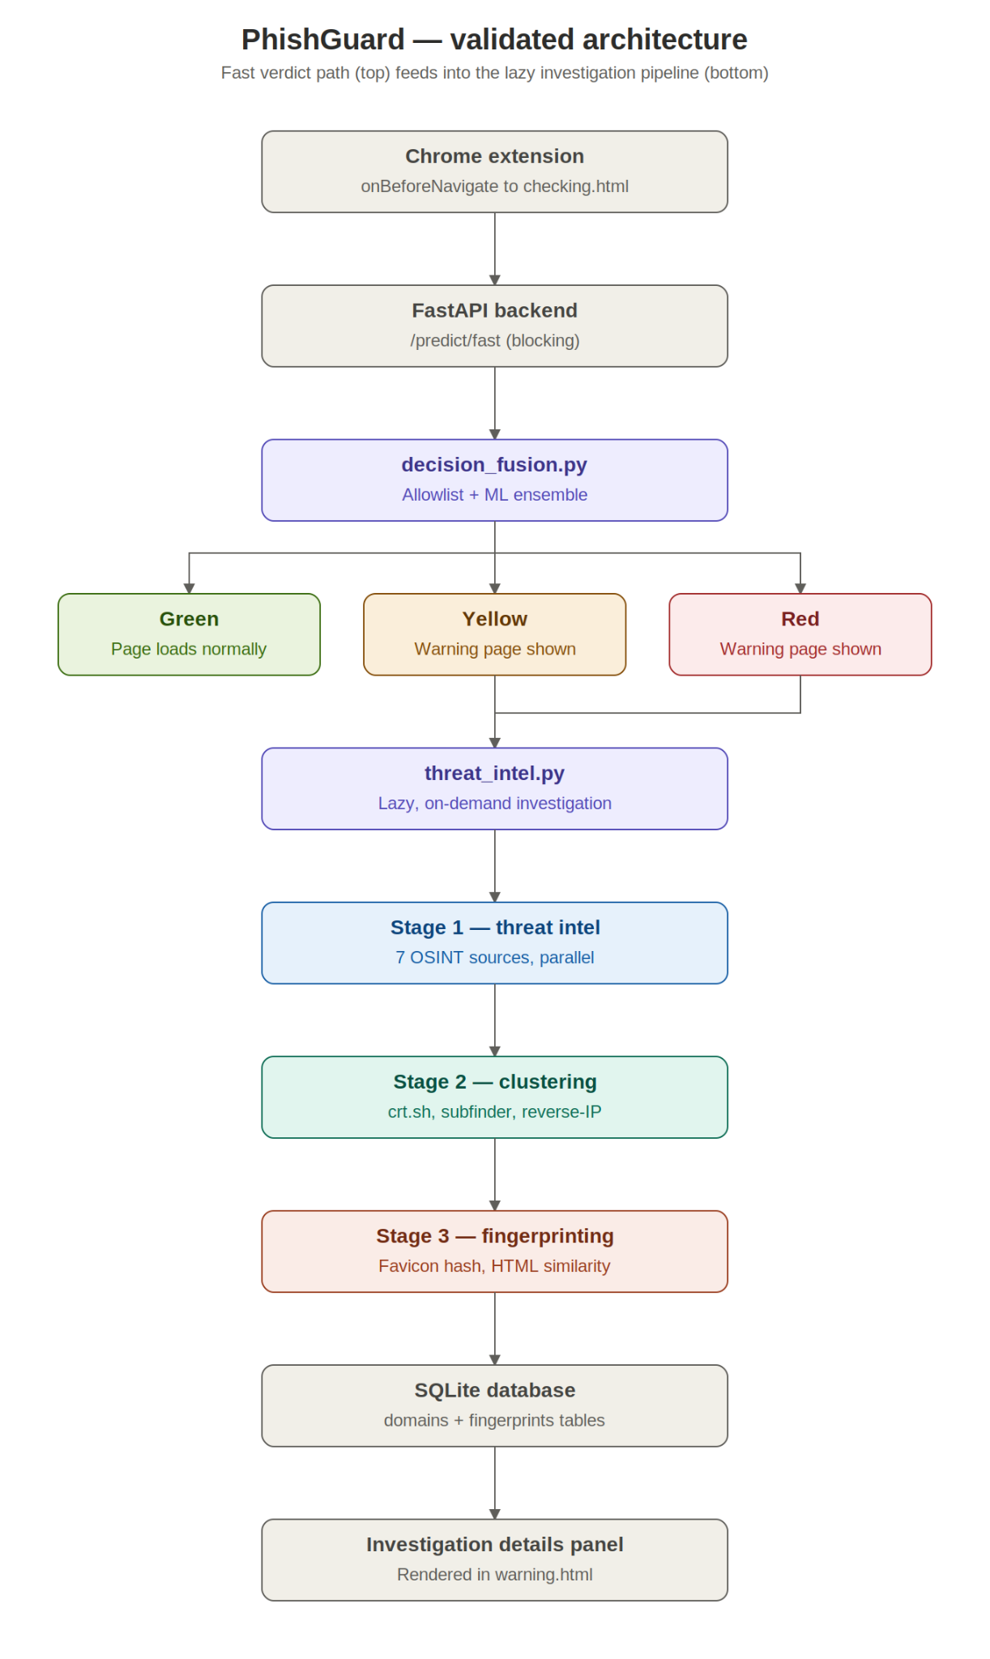
Figure 1: PhishGuard Lite System Architecture

Figure 4.1 illustrates the overall architecture of the proposed framework. When a user attempts to access a website, the Chrome extension intercepts the navigation request before the webpage is fully loaded. The requested URL is securely forwarded to the FastAPI backend, where feature extraction and machine learning-based classification are performed. Based on the prediction, the browser either allows normal navigation or displays an appropriate security warning before the user visits the webpage. For suspicious URLs requiring additional verification, the system automatically initiates a multi-stage threat intelligence investigation to collect supporting evidence from external security sources.
- To improve modularity and maintainability, the proposed framework is organized into five architectural layers, each responsible for a specific part of the phishing detection process.

Presentation Layer
- The Presentation Layer consists of the Chrome Extension, developed using Manifest V3. This layer serves as the primary interface between the user and the detection framework. It intercepts URL navigation requests through the background service worker, communicates with the backend prediction service, and presents the detection results through popup interfaces, browser badge notifications, and warning pages. By providing immediate visual feedback, the presentation layer enables users to make informed decisions before interacting with potentially malicious websites.

Application Layer
- The Application Layer is implemented using FastAPI, which acts as the communication bridge between the browser extension and the machine learning engine. It exposes RESTful API endpoints for real-time URL analysis, processes incoming prediction requests, executes the feature extraction pipeline, and returns structured JSON responses to the browser extension. Cross-Origin Resource Sharing (CORS) is configured to securely support communication from Chrome extension origins while maintaining low response latency for real-time operation.

Machine Learning Layer
- The Machine Learning Layer forms the core of the phishing detection framework. After receiving a URL, the system extracts both handcrafted lexical features and character-level textual representations using the TF-IDF vectorizer. These features are then analyzed by the XGBoost classifier, which detects known phishing patterns learned during supervised training, and the Isolation Forest, which identifies anomalous URLs that may represent previously unseen or zero-day phishing attacks. Finally, a decision fusion engine combines the outputs of both models to produce a unified phishing risk score that determines the appropriate alert level (Green, Yellow, or Red).

External Threat Intelligence Layer
- To improve detection reliability, the External Threat Intelligence Layer supplements machine learning predictions with evidence collected from multiple open-source intelligence (OSINT) services. This layer integrates Google Safe Browsing, VirusTotal, WHOIS records, certificate transparency logs (crt.sh), reverse-IP infrastructure analysis, and RapidFuzz-based brand similarity detection. These independent intelligence sources help verify suspicious URLs, identify malicious infrastructure, detect typosquatting attacks, and strengthen confidence in borderline classification decisions.

Data Layer
- The Data Layer manages all persistent resources required by the framework. It stores the trained machine learning models, serialized feature extraction artifacts such as the TF-IDF vocabulary and preprocessing objects, and an SQLite database (correlation.db) containing domain relationships, infrastructure fingerprints, investigation reports, and cached threat intelligence results. This layer also maintains prediction logs that support future analysis, reduce redundant external queries, and improve the efficiency of repeated investigations.
- Together, these five architectural layers form a flexible and extensible phishing detection framework capable of providing fast real-time predictions while supporting deeper post-detection investigations. The modular design allows individual components—including machine learning models, feature extraction methods, external intelligence services, and user interface elements—to be updated or replaced independently without affecting the overall system architecture. This separation of responsibilities improves scalability, simplifies maintenance, and enables the framework to adapt efficiently to evolving phishing techniques and emerging threat intelligence sources.

4.2 URL Feature Extraction and Classification
The URL feature extraction and classification module forms the core of the PhishGuard Lite detection framework. Its primary objective is to transform a raw URL into a comprehensive numerical representation that can be efficiently analyzed by machine learning models to determine whether the URL is legitimate or malicious. Rather than relying on manually defined rules or signature-based detection alone, the proposed framework adopts a hybrid machine learning approach capable of recognizing both known phishing patterns and previously unseen attacks.
When a URL is received by the FastAPI backend, it first passes through the feature extraction pipeline, where multiple characteristics of the URL are analyzed. The system combines 32 handcrafted lexical and structural features with 3,000 character-level TF-IDF features to generate a comprehensive 3,032-dimensional feature vector for each URL. The handcrafted features capture measurable properties such as URL length, domain characteristics, suspicious keywords, entropy, special-character usage, and other structural indicators commonly associated with phishing websites. In contrast, the TF-IDF representation captures subtle textual patterns, including brand-name fragments, typosquatting attempts, obfuscated strings, and recurring character sequences that frequently appear in malicious URLs.
The resulting feature vector serves as the input to the hybrid classification framework, which consists of two complementary machine learning models. The XGBoost classifier acts as the primary supervised learning component, identifying phishing URLs based on patterns learned from labeled training data. Alongside it, the Isolation Forest anomaly detector analyzes the same feature representation to identify URLs whose characteristics deviate significantly from normal behavior. This anomaly detection capability enables the framework to recognize suspicious URLs that may represent newly emerging or zero-day phishing attacks, even if similar examples were not present during training.
Finally, the outputs of both models are combined using the proposed decision fusion mechanism, producing a unified phishing risk score that is used to determine the final security level presented to the user. By integrating supervised classification with anomaly detection, the proposed framework improves both detection accuracy and robustness while maintaining the computational efficiency required for real-time browser-based phishing protection.

4.2.1 XGBoost Model Training Configuration

XGBoost was selected as the primary supervised algorithm for its strong classification performance, robustness to overfitting through regularization, and fast inference important for a real-time, in-browser use case.

Table 4.2.1.1: XGBoost Model Configuration and Training Parameters
Parameter | Value
Algorithm | XGBoost (Gradient-Boosted Trees)
n_estimators | 300
max_depth | 8
learning_rate | 0.1
subsample | 0.8
colsample_bytree | 0.8
Feature vector | 32 handcrafted + 3,000 TF-IDF = 3,032 dimensions
Dataset split | 80% train / 20% test (group-shuffle, by host)
Objective | Binary classification (logloss)
Model storage | xgboost_url_model.pkl
Deployment | FastAPI backend, loaded once at startup

4.2.2 Isolation Forest Model
To enhance the detection of previously unseen or zero-day phishing attacks, PhishGuard Lite incorporates an Isolation Forest as the anomaly detection component of the hybrid framework. Unlike supervised classifiers, which require labeled examples of both legitimate and phishing URLs, the Isolation Forest is trained exclusively on legitimate URLs. For this study, the model was trained using 119,164 legitimate URLs from the training dataset and utilized only the 32 handcrafted URL features.
By learning the normal structural and lexical characteristics of legitimate URLs, the model establishes a baseline representation of normal web addresses. During prediction, URLs that deviate significantly from this learned pattern are identified as anomalous and assigned a higher phishing risk. This enables the framework to detect suspicious URLs that exhibit unfamiliar or abnormal characteristics, even if similar phishing examples were not included in the training data.
The anomaly score generated by the Isolation Forest is not used as a standalone classification decision. Instead, it serves as a complementary signal that is combined with the prediction of the XGBoost classifier through the decision fusion mechanism. This hybrid approach improves the framework's ability to recognize emerging phishing attacks while maintaining reliable performance on legitimate websites.

The anomaly score for data point x in dataset of size n (Liu et al., 2008 [3]):

s(x, n) = 2 ^ ( -E[h(x)] / c(n) )

where E[h(x)] is the expected path length across all trees, c(n) = 2H(n-1) - 2(n-1)/n. Scores near 1.0 = anomalies; near 0.5 = normal.

4.2.3 Hybrid Decision Fusion
To improve the overall reliability of phishing detection, PhishGuard Lite combines the outputs of the XGBoost classifier and the Isolation Forest into a single fused risk score. This hybrid fusion strategy leverages the strengths of both models: the XGBoost classifier provides accurate supervised predictions for known phishing patterns, while the Isolation Forest contributes anomaly-based information that helps identify previously unseen or zero-day attacks. Combining these complementary outputs results in a more robust and balanced detection framework than relying on either model independently.
The fused risk score is calculated using a weighted combination of the supervised prediction probability and the normalized anomaly score:
Fused Score = 0.70 × XGBoost Probability + 0.30 × Normalized Anomaly Score ( + Safe Browsing Bonus if blacklisted )
Before fusion, the anomaly score produced by the Isolation Forest is min–max normalized using percentile values obtained from the training dataset. This normalization ensures that the outputs of both models are represented on a comparable scale, allowing the weighted fusion process to generate a meaningful and consistent risk score.
To further strengthen detection reliability, the framework incorporates Google Safe Browsing as an independent verification source. If a URL is confirmed to be present in the Safe Browsing blacklist, a predefined bonus is added to the fused risk score. This additional evidence ensures that URLs already identified as malicious by a trusted external security service receive an appropriately high risk score, even if the machine learning models alone produce a lower prediction. Consequently, the final fused score combines supervised learning, anomaly detection, and external threat intelligence to provide a more accurate and dependable phishing assessment.

The raw anomaly score is first normalized to [0, 1] using percentile-based min-max scaling:

A_norm = clip( (A_raw - A_min) / (A_max - A_min), 0, 1 )

where A_min = 5th percentile, A_max = 99th percentile of training scores. The fused risk score:

S_fused = w_sup x P_XGBoost + w_anom x A_norm

where w_sup = 0.70, w_anom = 0.30. If Safe Browsing confirms the URL is blacklisted:

S_final = min( S_fused + B_SB, 1.0 )

Fused Score = 0.70 × XGBoost Probability + 0.30 × Normalized Anomaly Score ( + Safe Browsing Bonus if blacklisted )

Before fusion, the anomaly score produced by the Isolation Forest is min–max normalized using percentile values obtained from the training dataset. This normalization ensures that the outputs of both models are represented on a comparable scale, allowing the weighted fusion process to generate a meaningful and consistent risk score.

To further strengthen detection reliability, the framework incorporates Google Safe Browsing as an independent verification source. If a URL is confirmed to be present in the Safe Browsing blacklist, a predefined bonus is added to the fused risk score. This additional evidence ensures that URLs already identified as malicious by a trusted external security service receive an appropriately high risk score, even if the machine learning models alone produce a lower prediction. Consequently, the final fused score combines supervised learning, anomaly detection, and external threat intelligence to provide a more accurate and dependable phishing assessment.

4.3 Risk Score Calculation and Alert Thresholds
The fused score is converted into a three-tier alert using thresholds selected directly from the ROC curve of the fused score on the held-out test set, targeting a 3% false-positive rate for the RED tier and a 12% false-positive rate for the YELLOW tier:
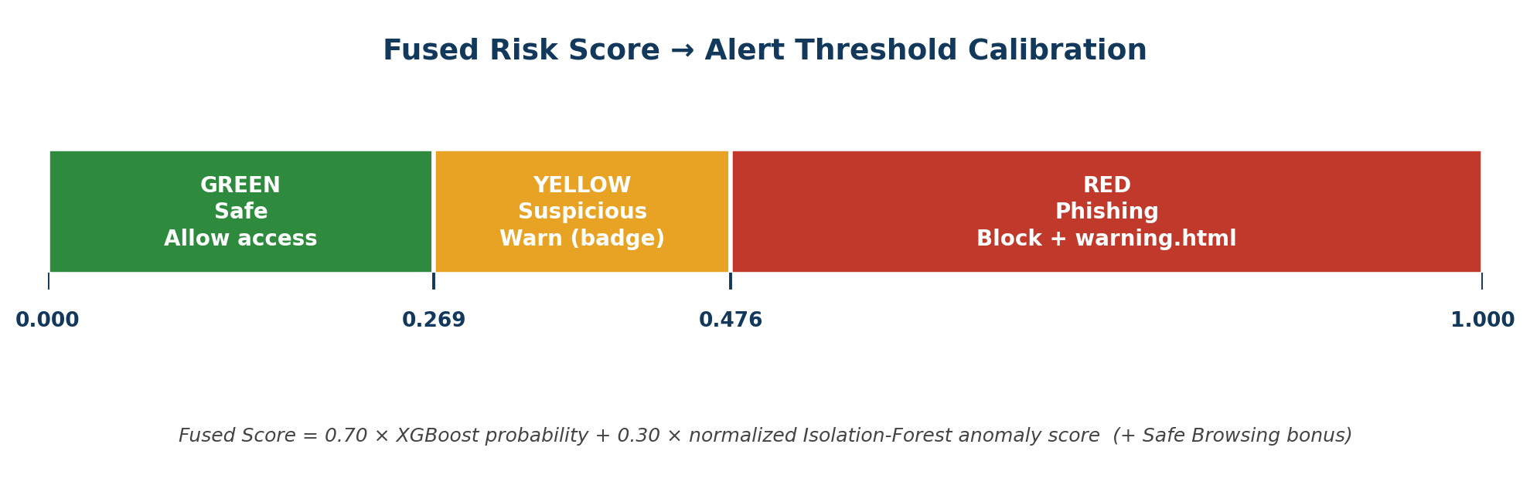
Figure 2: Fused-Score Alert Threshold Calibration (GREEN / YELLOW / RED)
Formally, the three-tier alert classification:
Alert(S) = GREEN if S below 0.269; YELLOW if 0.269 to 0.476; RED if 0.477 or above

Table 4.3.1: Phishing Alert Levels and Decision Thresholds
Alert Level | Fused Score Threshold | Action
GREEN (Safe) | below 0.269 | Allow website access
YELLOW (Suspicious) | 0.269 – 0.476 | Display warning notification (non-blocking badge)
RED (Phishing) | 0.477 and above | Redirect to warning.html and block access

4.4 Multi-Stage Threat Intelligence and Infrastructure Correlation
Beyond per-URL scoring, the backend's threat_intel.py orchestrator performs a deeper, asynchronous open-source investigation of any URL escalated past the initial ML score, organized into three stages that run in parallel where possible to minimize latency:
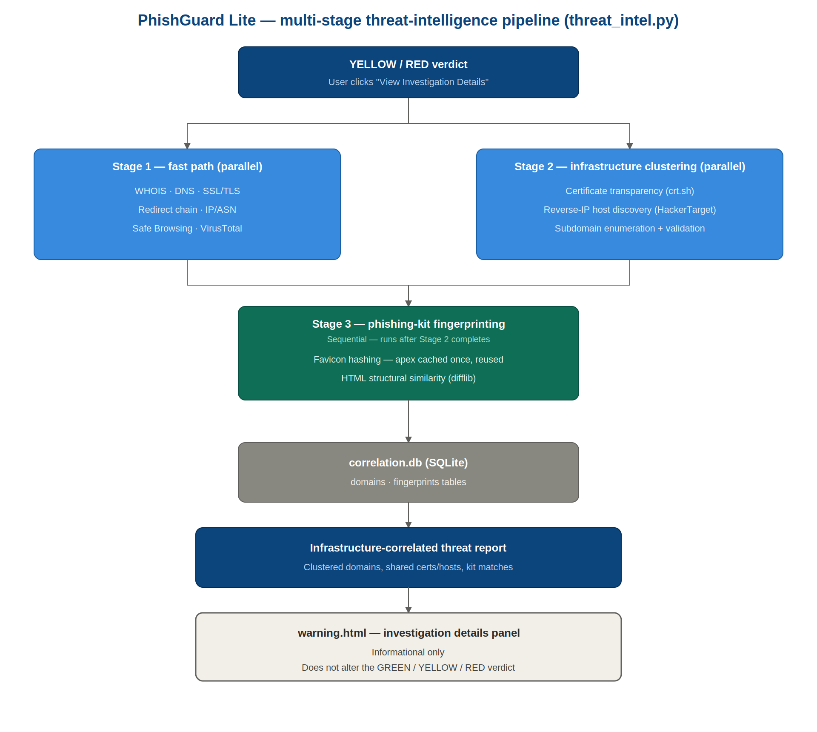
Figure 3: Multi-Stage Threat-Intelligence Pipeline (threat_intel.py)

Stage 1 — Fast Lookups (Fast Path)
WHOIS domain-age lookup, DNS resolution, SSL/TLS certificate inspection, redirect-chain tracing, IP/ASN/hosting-provider lookup, Google Safe Browsing verification, and VirusTotal verification are dispatched concurrently through a thread pool, typically completing in one to three seconds.

Stage 2 — Infrastructure Clustering
For URLs that warrant deeper investigation, certificate-transparency search (crt.sh) surfaces sibling domains sharing a certificate, reverse-IP lookup identifies other domains hosted on the same server or ASN, and subdomain enumeration with liveness validation discovers active subdomains of the apex domain. Findings are persisted to a SQLite correlation database (domains, fingerprints, reports tables) so that repeated infrastructure across multiple reported URLs can be clustered over time.

Stage 3 — Phishing-Kit Fingerprinting
Favicon hashing (with the apex-domain favicon cached once and reused across all discovered subhosts, rather than re-fetched per host) and HTML/JavaScript structural fingerprinting compare the visual and code-level fingerprint of a suspicious page against known phishing-kit templates, helping identify mass-deployed phishing kits reused across many domains.

4.5 Browser Extension Integration
The PhishGuard Lite browser extension is built on Chrome Extension Manifest V3 and serves as the primary interface between the user and the detection system. Its background service worker monitors the active tab, extracts the visited URL, and sends it to the FastAPI backend for scoring.
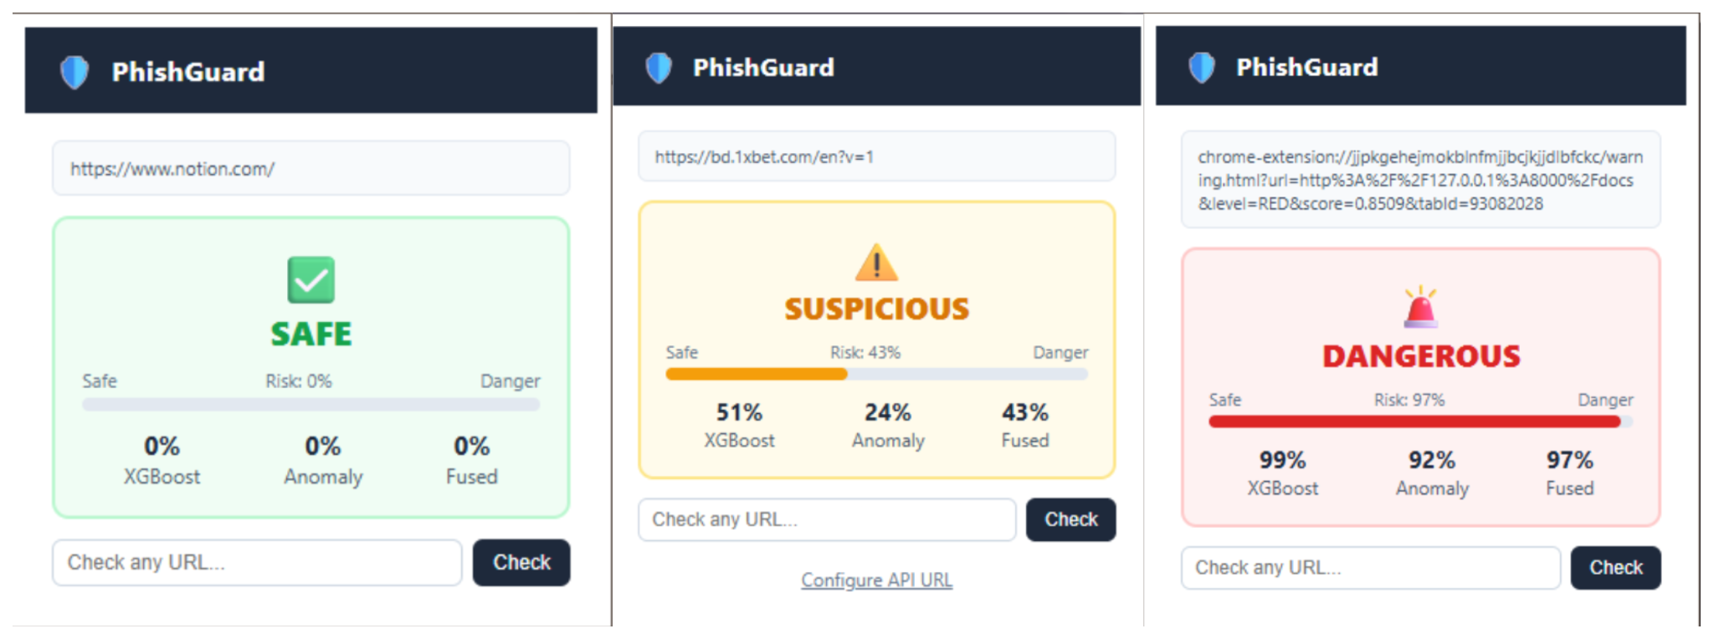
Figure 4: Browser Extension — GREEN / YELLOW / RED Alert States

Browser Extension Workflow
The browser extension operates as the first point of interaction between the user and the phishing detection framework. Its workflow consists of five sequential stages, enabling real-time URL analysis with minimal impact on browsing performance.

URL Capture
- When a user navigates to a webpage, the extension's background service worker intercepts the navigation request and captures the active tab's URL before the webpage is fully loaded.

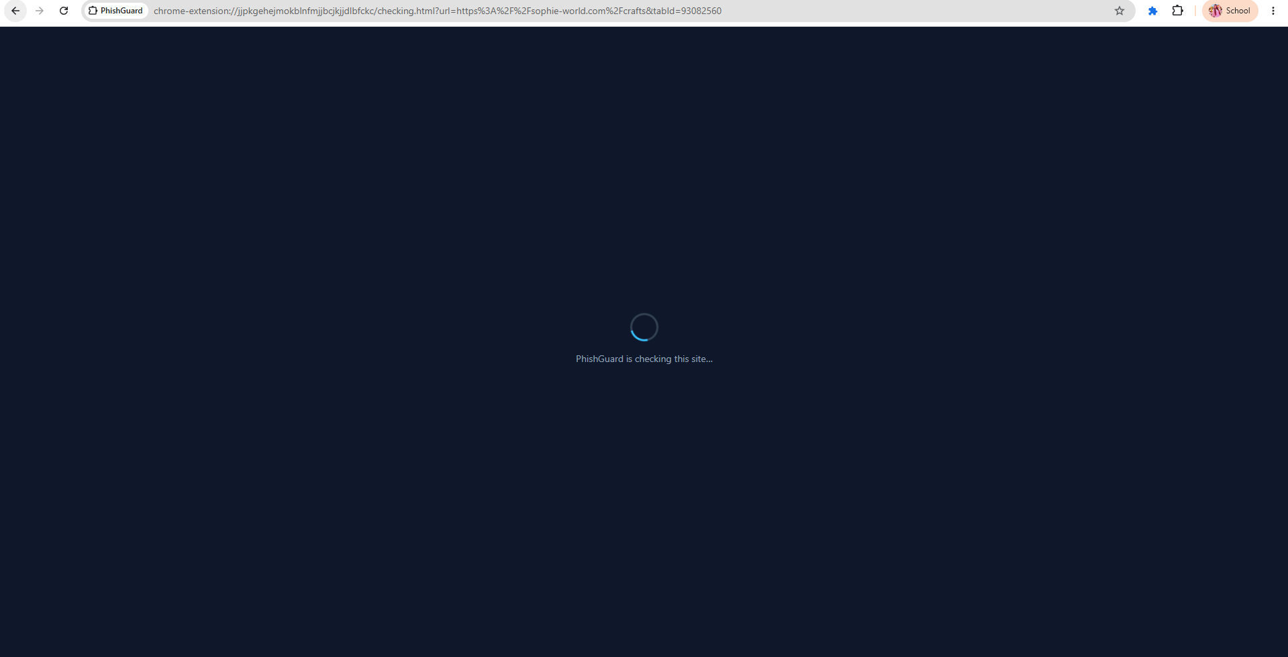
Figure 4.1 : Loading page – "PhishGuard is checking this site..."

Backend Analysis
- The captured URL is forwarded to the FastAPI backend through the /analyze endpoint. The backend extracts the 32 handcrafted URL features and 3,000 character-level TF-IDF features, which are then evaluated using the XGBoost classifier and the Isolation Forest anomaly detector.

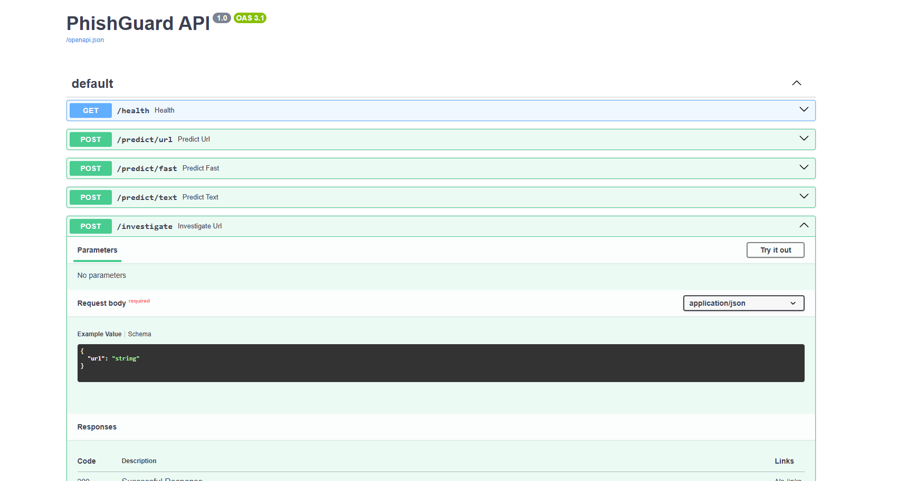
Figure 4.2 : Swagger API showing POST /predict/url endpoint

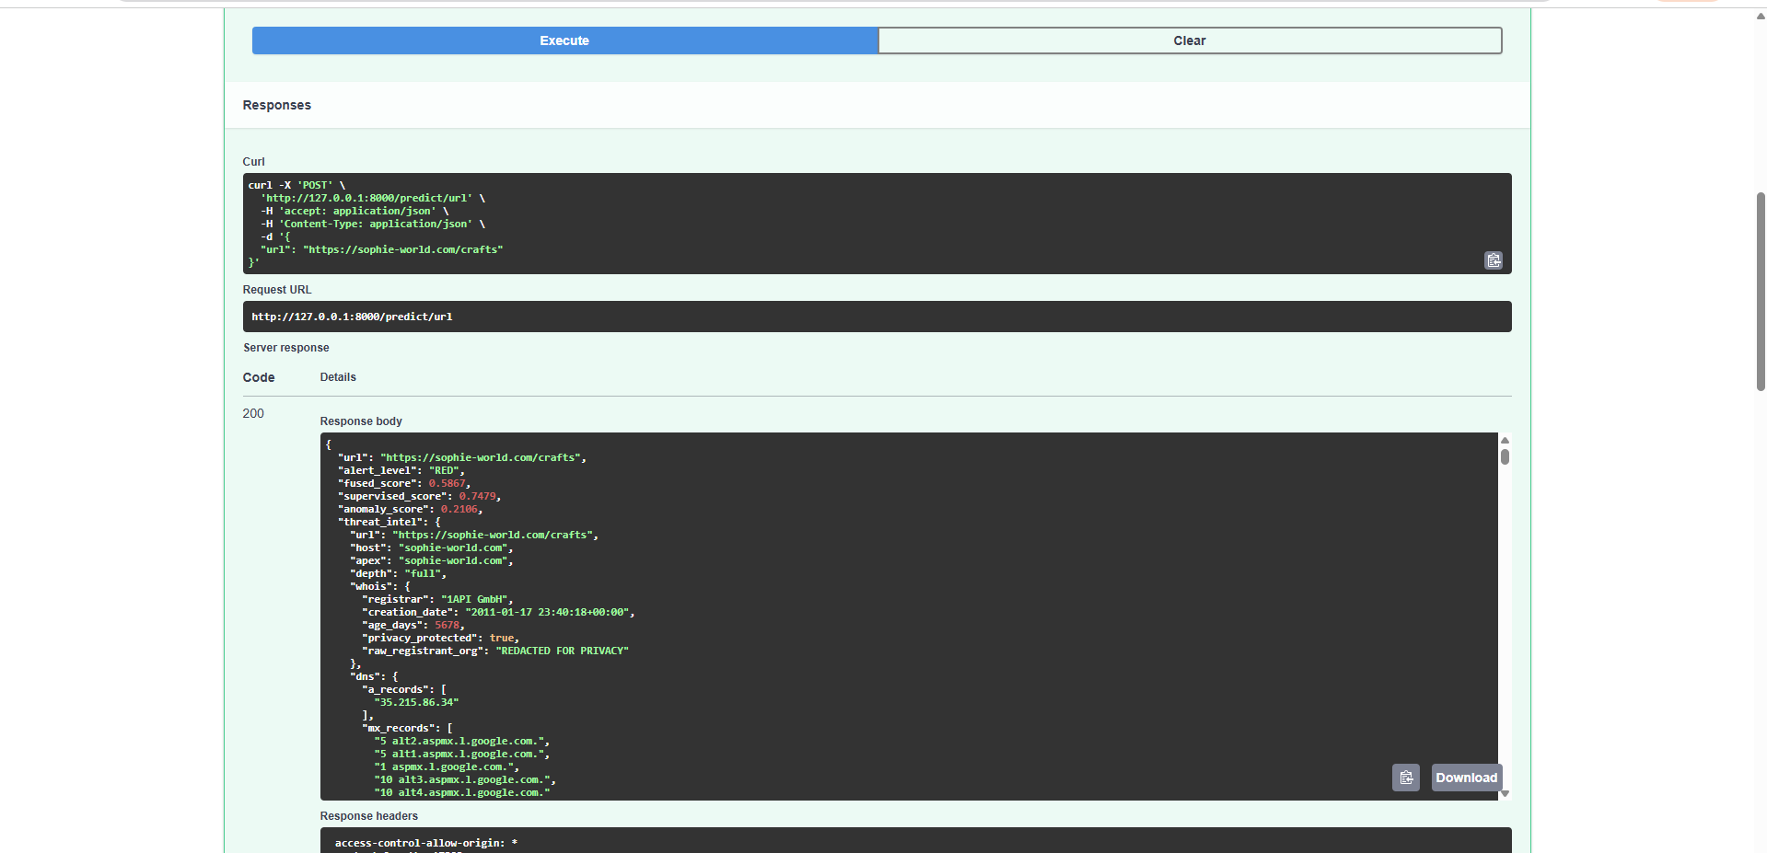
Figure 4.3 : Swagger Response JSON showing fused_score, supervised_score, anomaly_score, threat_intel, etc.

Threat Intelligence Verification
- To improve detection reliability, the prediction is supplemented with Google Safe Browsing verification. When additional validation is required, the system invokes the multi-stage threat intelligence pipeline to collect supporting evidence from external intelligence sources.
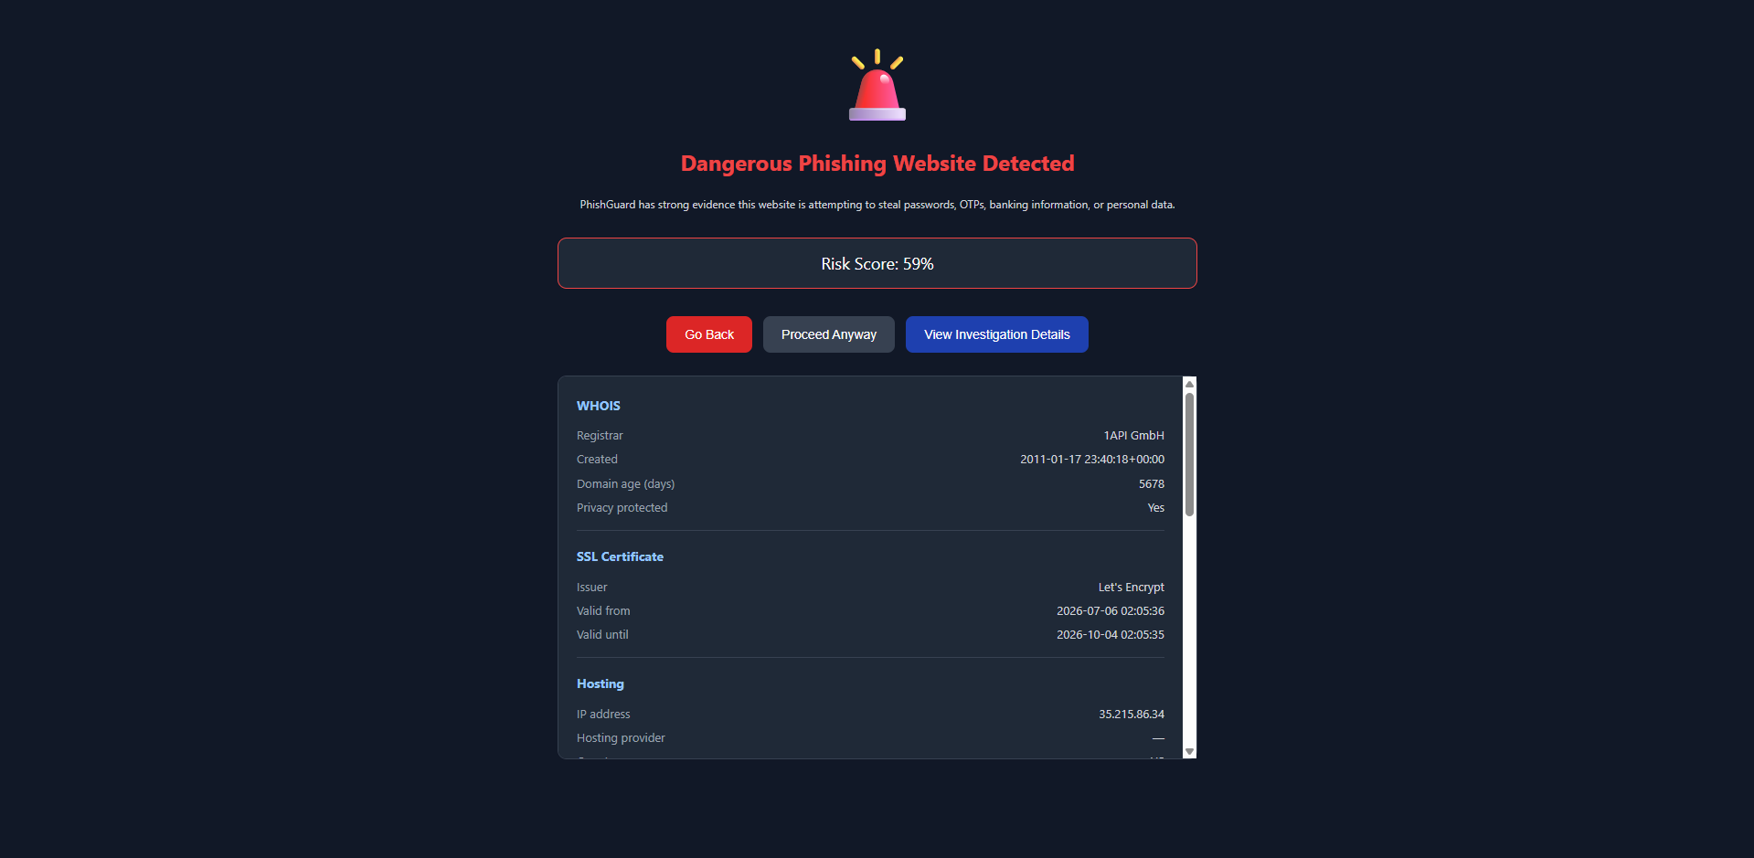
Figure 4.4 : Investigation Details showing WHOIS, SSL, Hosting, Google Safe Browsing, VirusTotal, Infrastructure Clustering

Risk Score Generation
- The outputs of the machine learning models and external verification are combined through the hybrid decision fusion mechanism to compute a unified phishing risk score. Based on this score, the URL is classified into one of three alert levels: GREEN, YELLOW, or RED.
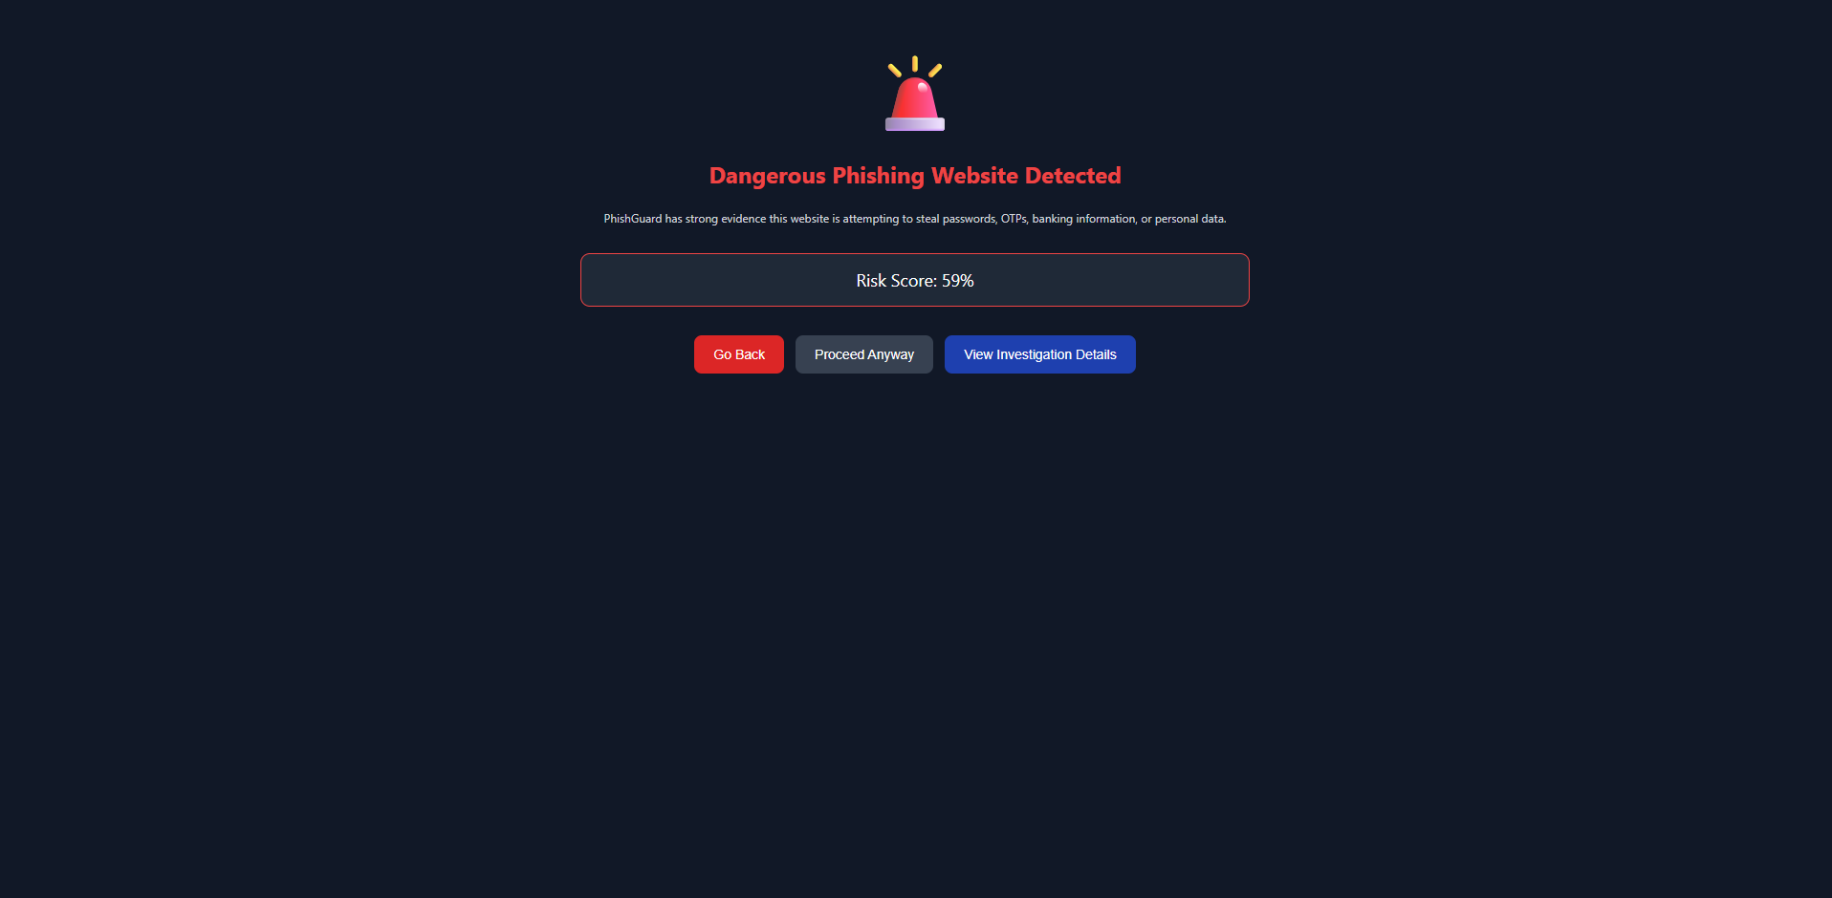
Figure 4.5 : Dangerous Phishing Website Detected page (Risk Score 59%) .

User Notification
- The final prediction is returned to the browser extension in JSON format. URLs classified as GREEN or YELLOW are displayed through the extension popup and browser badge, whereas RED alerts redirect users to a dedicated warning.html interstitial page. This full-page warning provides greater visibility and is more effective at preventing users from proceeding to high-risk phishing websites than an in-page notification.
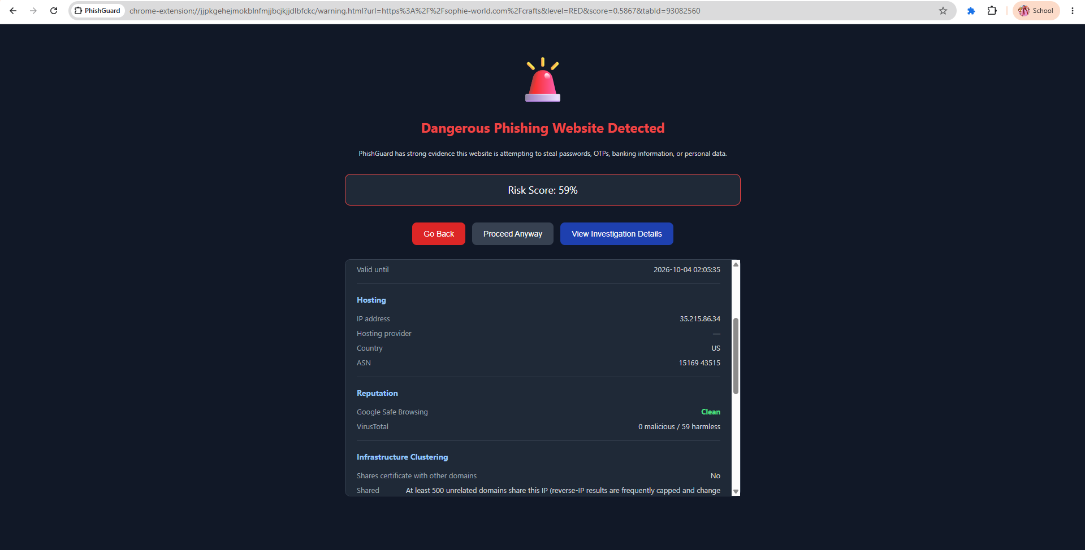
Figure 4.6 : Warning page with Investigation Details expanded .


Figure 4.6 : Extension Popup showing DANGEROUS (59% risk) on sophie-world.com

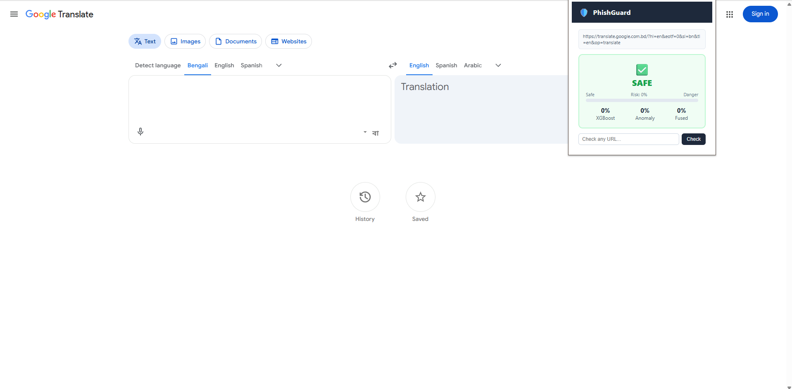
Figure 4.6 : Extension Popup showing SAFE (Google Translate) .

5. Experimental Results and Performance Analysis

5.1 Evaluation Protocol and Metrics
Both models were evaluated on the same held-out, group-shuffled test set of 62,474 URLs (31,638 phishing, 30,836 legitimate) that was never used during TF-IDF fitting or model training. Evaluation metrics include accuracy, precision, recall, F1-score, ROC-AUC, and false-positive rate (FPR), with particular attention to FPR since an overly aggressive detector that blocks legitimate sites quickly erodes user trust.
The following definitions apply.
Positive class = phishing; negative class = legitimate. TP = phishing correctly flagged; TN = legitimate correctly passed; FP = legitimate incorrectly flagged; FN = phishing missed.
Accuracy = (TP + TN) / (TP + TN + FP + FN) (1)
Precision = TP / (TP + FP) (2)
Recall = TP / (TP + FN) (3)
F1 = 2 x (Precision x Recall) / (Precision + Recall) (4)
FPR = FP / (FP + TN) (5)
The ROC curve plots TPR (= Recall) against FPR at every threshold. AUC summarizes discrimination; 1.0 = perfect, 0.5 = random:
AUC = integral from 0 to 1 of TPR(FPR) d(FPR) (6)
Precision@Top-k% measures the fraction of true phishing among the k% with highest anomaly scores:
Precision@Top-k% = (Phishing in top k%) / (Total in top k%) (7)

5.2 XGBoost Classifier Performance
The XGBoost classifier achieved an overall accuracy of 91.3% and a ROC-AUC of 0.970 on the held-out test set, with a false-positive rate of 4.18% close to the project's 5% FPR target.

Table 5.2.1: Performance Evaluation of the XGBoost Classifier on the Test Dataset
Class | Precision | Recall | F1-score | Support
Legitimate | 0.8773 | 0.9582 | 0.9160 | 30,836
Phishing | 0.9553 | 0.8694 | 0.9103 | 31,638
Accuracy | — | — | 0.9132 | 62,474
Macro avg | 0.9163 | 0.9138 | 0.9131 | 62,474
Weighted avg | 0.9168 | 0.9132 | 0.9131 | 62,474

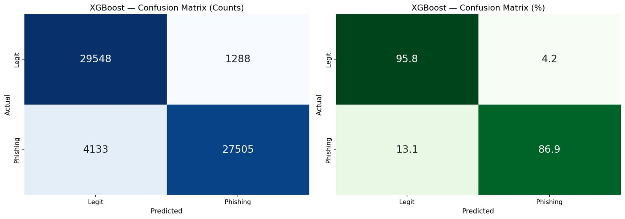
Figure 5: XGBoost Confusion Matrix — Counts (left) and Row-Normalized Percentages (right)
The confusion matrix shows 29,548 true negatives, 1,288 false positives, 4,133 false negatives, and 27,505 true positives. XGBoost correctly identifies 95.8% of legitimate URLs and 86.9% of phishing URLs, reflecting a deliberately conservative bias toward avoiding false alarms on legitimate sites.

5.3 Isolation Forest Anomaly Detector Performance

Overall Performance

The Isolation Forest achieved a ROC-AUC of 0.723 and an F1-score of 0.534 when evaluated as a standalone binary classifier. Its performance is lower than that of the XGBoost classifier, which is expected because the model is trained exclusively on legitimate URLs and does not use labeled phishing examples during training. Instead of learning explicit phishing patterns, the model establishes a representation of normal URL behavior and identifies URLs that significantly deviate from this learned distribution.
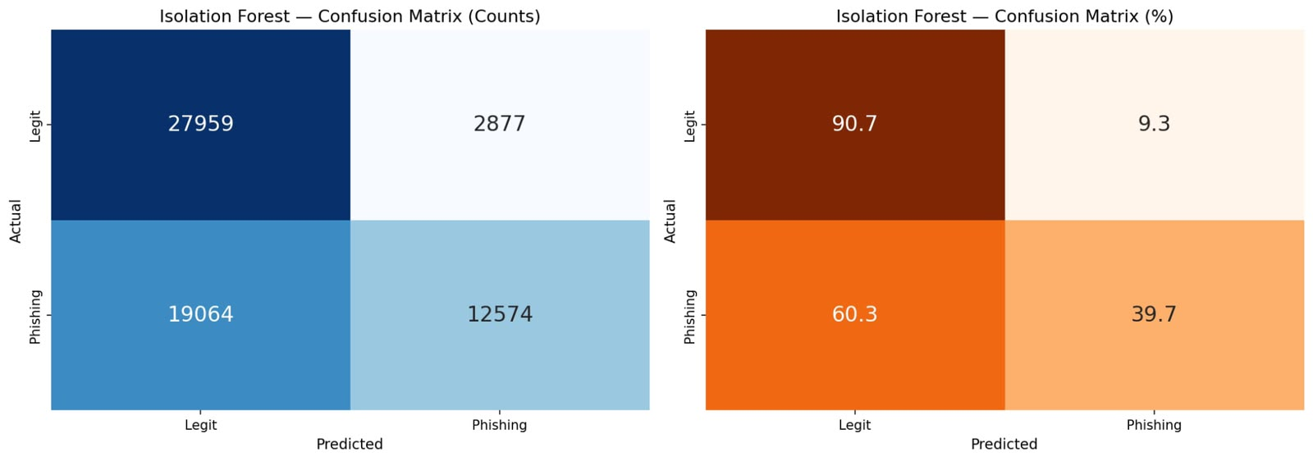
Figure 6: Isolation Forest Confusion Matrix — Counts (left) and Row-Normalized Percentages (right)

Confusion Matrix Analysis
The confusion matrix reveals that the Isolation Forest produced a substantially higher number of false negatives (19,064) compared with the supervised XGBoost classifier. This behavior is characteristic of an unsupervised anomaly detection model, whose objective is to identify genuinely unusual URLs rather than reproduce the decision boundary between legitimate and phishing classes learned from labeled data. Consequently, the model correctly identified 39.7% of phishing URLs as anomalous while correctly classifying 90.7% of legitimate URLs as normal. These results indicate that the Isolation Forest is conservative in its predictions, prioritizing the preservation of legitimate websites while flagging only URLs that exhibit strong anomalous characteristics.

Contribution to the Hybrid Framework
Although the Isolation Forest is not intended to function as the primary phishing classifier, it provides an important complementary capability by detecting suspicious URLs that differ from previously observed phishing patterns. This makes the model particularly valuable for identifying zero-day or emerging phishing attacks that may not be well represented in the labeled training data.

Detection of Highly Anomalous URLs
The effectiveness of the anomaly detector is further demonstrated by its Precision@Top-5% result. Among the 5% most anomalous URLs identified by the model, 91.7% were confirmed to be phishing websites (Precision@Top-5% = 0.9174). This high precision indicates that URLs assigned the highest anomaly scores are highly likely to be malicious, validating the inclusion of the Isolation Forest as a secondary signal within the hybrid decision fusion framework. Rather than replacing the supervised classifier, the anomaly detector enhances the overall robustness of the system by providing additional evidence for suspicious URLs that may otherwise be overlooked.

5.4 ROC Curve Comparison

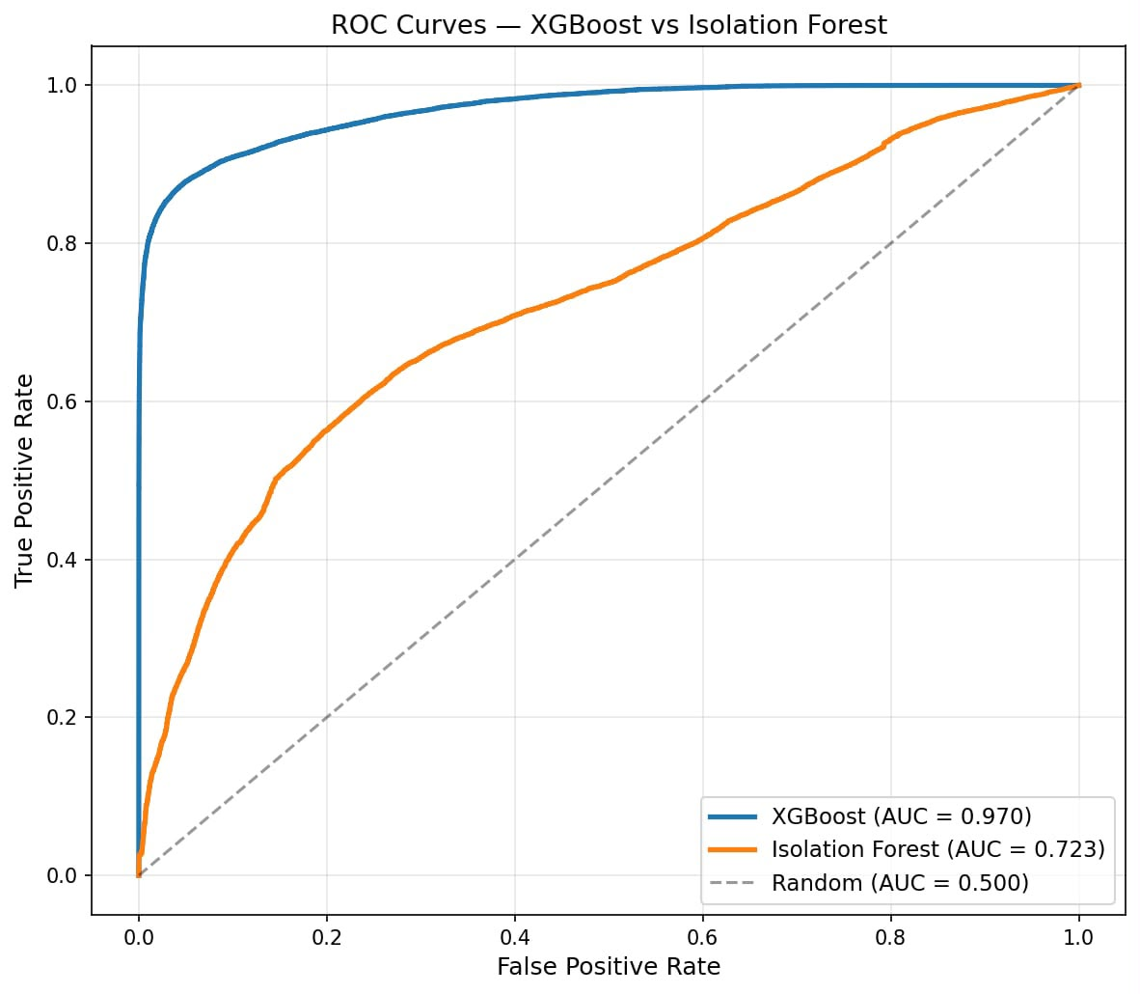
Figure 7: ROC Curves — XGBoost (AUC = 0.970) vs Isolation Forest (AUC = 0.723) vs Random Baseline (AUC = 0.500)
The ROC comparison makes the complementary role of the two models explicit: XGBoost's curve rises sharply toward the top-left corner, reflecting near-optimal discrimination once labelled examples are available, while the Isolation Forest curve sits well above the random baseline but far below XGBoost, confirming its role as a secondary, zero-day-oriented signal rather than a primary classifier.

5.4.1 Comparative Model Evaluation

To validate the selection of XGBoost and Isolation Forest as the final classifier and anomaly detector, both models were benchmarked against five alternative machine learning algorithms trained and evaluated on the identical feature set (32 handcrafted features combined with 3,000-dimensional TF-IDF vectors) and the same train-test split. Random Forest, Logistic Regression (L2-regularized), and SGDClassifier (linear SVM with hinge loss) were compared against XGBoost as supervised alternatives, while Local Outlier Factor and One-Class SVM were compared against Isolation Forest as anomaly-detection alternatives. LightGBM was initially included but was excluded from the final comparison after a persistent native-library crash on the Windows test environment could not be resolved despite troubleshooting (sparse-matrix format correction, single-threaded execution, and Visual C++ Redistributable verification).

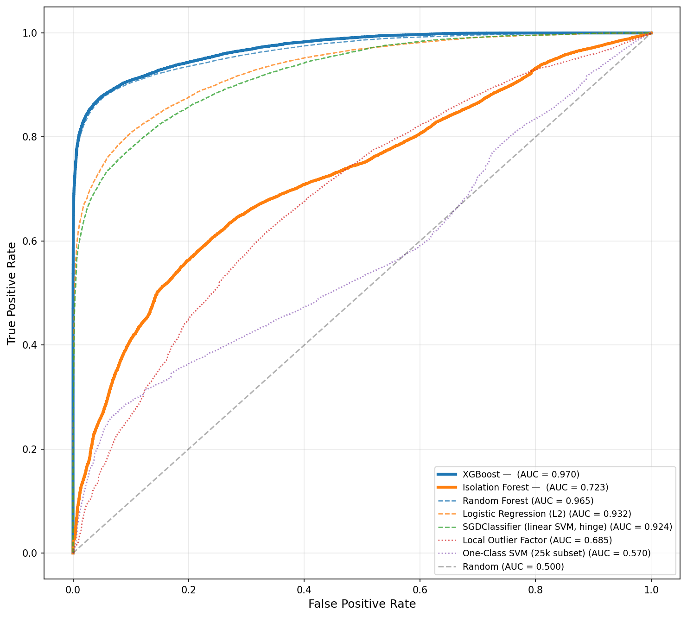
Figure 7b: ROC Curves — All 8 Models

Table 5.4.1: Supervised Classifier Comparison

Model | Accuracy | Precision | Recall | F1 Score | ROC-AUC
XGBoost | 0.9132 | 0.9553 | 0.8694 | 0.9104 | 0.970
Random Forest | 0.9111 | 0.9485 | 0.8718 | 0.9085 | 0.965
Logistic Regression (L2) | 0.8532 | 0.8885 | 0.8121 | 0.8486 | 0.932
SGDClassifier (linear SVM, hinge) | 0.8383 | 0.8962 | 0.7699 | 0.8283 | 0.924

Table 5.4.2: Anomaly Detector Comparison

Model | Accuracy | Precision | Recall | F1 Score | ROC-AUC
Isolation Forest | 0.6488 | 0.8138 | 0.3975 | 0.5341 | 0.723
Local Outlier Factor | 0.6006 | 0.7055 | 0.3628 | 0.4791 | 0.685
One-Class SVM (25k subset) | 0.5909 | 0.7372 | 0.2985 | 0.4249 | 0.570

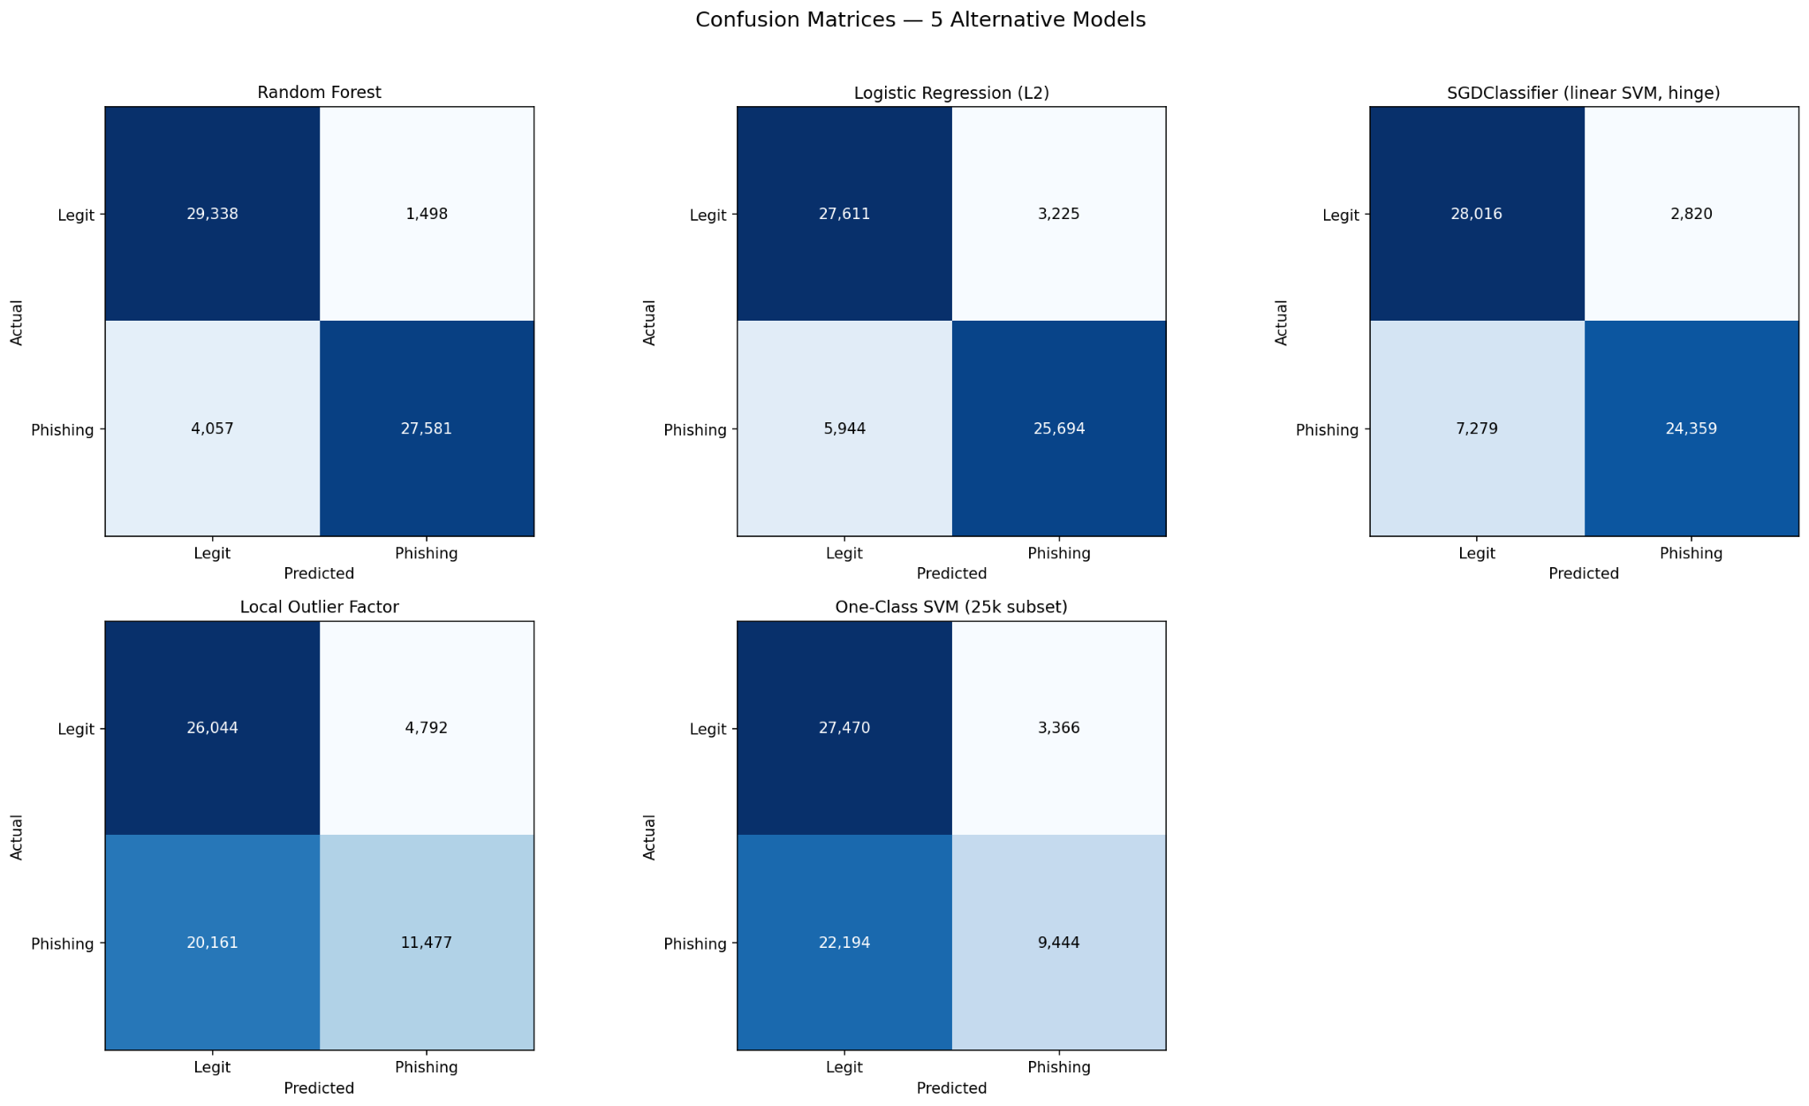

Figure 7c: Confusion Matrices for the Five Alternative Models

Among the supervised classifiers, XGBoost achieved the highest F1-score (0.910) and ROC-AUC (0.970), narrowly outperforming Random Forest (0.965 AUC) while requiring substantially less training time — Random Forest took 194.6 seconds to train under the same configuration, compared to a few seconds for XGBoost. Both linear models (Logistic Regression, SGDClassifier) trailed noticeably behind, confirming that the phishing/legitimate decision boundary in this feature space is non-linear and better captured by tree-based ensembles. Among the anomaly detectors, Isolation Forest again achieved the best F1-score (0.534) and ROC-AUC (0.723), while training in a fraction of the time required by Local Outlier Factor (255.2s) and One-Class SVM (146.6s on a 25,000-sample subset, as training on the full dataset was computationally infeasible for this algorithm). XGBoost and Isolation Forest were therefore selected not only for their superior detection performance but also for their practical suitability for a lightweight, real-time deployment, where inference and training efficiency are as important as raw accuracy.

5.5 Decision Fusion and Alert-Threshold Calibration
Alert thresholds for the fused score (Section 4.3) were chosen directly from the ROC curve of the fused, weighted score on the test set, targeting a 3% false-positive rate for the RED tier and a 12% false-positive rate for the YELLOW tier:
Table 5.5.1: Performance of the Phishing Alert Tiers
Alert Tier | Phishing Caught (Recall) | False-Alarm Rate on Legitimate URLs
RED only | 84.9% | 3.0%
RED + YELLOW (any flag) | 91.1% | 12.0%

A separate simulation modelling a realistic phishing prevalence of roughly 2% (i.e., most URLs a user actually visits are legitimate) shows that when the fused score does raise a RED alert, it is correct 96.7% of the time, and any flag (RED or YELLOW) is correct 88.6% of the time, while still catching 91.1% of the phishing URLs a user would realistically encounter.

Table 5.5.2: Real-World Performance Metrics of PhishGuard Lite
Metric (at ~2% real-world phishing prevalence) | Value
RED-alert precision | 96.7%
Any-flag (RED or YELLOW) precision | 88.6%
Phishing recall | 91.1%

5.6 Discussion of Results

5.6.1 Overall Performance
The experimental results demonstrate that the proposed hybrid phishing detection framework achieves a strong balance between detection accuracy, computational efficiency, and practical deployment. By combining supervised learning, anomaly detection, and external threat intelligence, the system effectively identifies both known phishing attacks and previously unseen threats while maintaining real-time performance.

5.6.2 Effectiveness of the Hybrid Detection Framework
The XGBoost classifier serves as the primary detection model, achieving excellent predictive performance (AUC = 0.970) with low inference latency. Integrating the Isolation Forest anomaly score further strengthens the framework by improving the detection of anomalous and zero-day phishing URLs. This hybrid approach increases system robustness while maintaining a low false-positive rate for legitimate websites.

5.6.3 Contribution of External Threat Intelligence
The integration of Google Safe Browsing and the infrastructure-correlation pipeline provides an additional verification layer beyond machine learning predictions. These independent sources of security intelligence help validate suspicious URLs, reduce uncertainty in borderline cases, and improve the reliability of the final classification decision.

5.6.4 Practical Implications
The evaluation demonstrates that the proposed architecture is suitable for deployment in real-world browser extensions. Despite combining multiple detection components, the framework maintains the low latency required for real-time URL analysis. This makes the system practical for everyday web browsing without introducing noticeable performance overhead.

5.6.5 Key Findings
The overall findings indicate that a lightweight hybrid framework based on classical machine learning, anomaly detection, and external threat intelligence can provide accurate and reliable phishing detection without the computational complexity of deep learning models. This combination offers a scalable and efficient solution capable of adapting to evolving phishing techniques while meeting the performance requirements of modern browser-based security systems.

6. Discussion, Limitations, and Future Work

6.1 Discussion of System Performance
- The experimental evaluation demonstrates that PhishGuard Lite provides an effective and practical solution for real-time phishing detection in browser environments. The proposed hybrid framework combines supervised learning, anomaly detection, and external threat intelligence to overcome the limitations of relying on a single detection technique. While the XGBoost classifier accurately identifies known phishing patterns, the Isolation Forest enhances robustness by recognizing anomalous URLs that deviate from previously observed behaviors. This complementary design improves the framework's resilience against emerging phishing attacks without significantly increasing false-positive predictions.
- A key strength of the proposed system is its lightweight architecture. Unlike deep learning approaches that often require substantial computational resources, the combination of TF-IDF character-level features, handcrafted URL-based features, and classical machine learning achieves high detection accuracy with low inference latency. This makes the framework well suited for deployment as a browser extension, where rapid URL analysis is essential to avoid disrupting the user's browsing experience.
- The integration of multiple open-source threat intelligence services further strengthens the reliability of the detection process. Google Safe Browsing, VirusTotal, WHOIS analysis, and infrastructure-correlation techniques provide independent evidence that complements machine learning predictions. Rather than relying solely on classification probabilities, the system validates suspicious URLs using external reputation and infrastructure information, reducing uncertainty in borderline cases and increasing confidence in the final decision.
- Another important contribution is the modular system architecture. The Chrome extension communicates with a FastAPI backend through a well-defined API, allowing detection models, feature extractors, and intelligence sources to be updated independently. This modularity improves maintainability and enables the framework to evolve as phishing techniques and threat intelligence sources continue to change.
- Overall, the results indicate that combining classical machine learning with anomaly detection and external security intelligence provides a practical balance between detection accuracy, computational efficiency, scalability, and real-world deployability.

6.2 Study Limitations
- Although the proposed framework achieves promising performance, several limitations should be considered when interpreting the results.
- Dependence on URL-Based Features:
The primary detection pipeline focuses on lexical and structural characteristics of URLs. While this approach enables fast and efficient classification, it does not analyze webpage content, HTML structure, JavaScript behavior, visual similarity, or user-interface elements. Consequently, sophisticated phishing websites that closely resemble legitimate pages while using benign-looking URLs may not always be detected.
- Dependence on Historical Training Data:
The supervised learning model is trained using historical phishing datasets. As phishing techniques continuously evolve, the model's effectiveness may gradually decline if it is not periodically retrained with recent attack samples. Similarly, anomaly detection performance depends on accurately representing the distribution of legitimate URLs.
- Reliance on External Threat Intelligence:
The framework incorporates external services such as Google Safe Browsing, VirusTotal, and WHOIS to strengthen detection reliability. However, these services introduce additional network latency and may not immediately recognize newly registered or previously unseen malicious domains. API availability, rate limits, and temporary service interruptions may also affect system performance.
- Evaluation Scope:
The experimental evaluation was conducted primarily on publicly available benchmark datasets and controlled testing environments. Although these datasets provide a reliable basis for performance assessment, they cannot fully capture the diversity and rapid evolution of phishing attacks encountered in real-world browsing scenarios. Long-term deployment studies involving live internet traffic would provide a more comprehensive evaluation.
- Platform Compatibility:
The current implementation is designed for Chromium-based browsers. Consequently, its performance and compatibility have not yet been evaluated for Firefox, Safari, or mobile browser platforms.
- Standalone Anomaly Detection Performance:
The Isolation Forest model alone produces lower predictive performance than the supervised classifier. Its primary value lies in identifying anomalous URL patterns that may represent previously unseen phishing attacks. Therefore, it is most effective when used as a complementary component within the hybrid detection framework rather than as an independent classifier.

6.3 Future Work and Research Directions
- Several opportunities exist to further improve the proposed framework and extend its applicability.
- Webpage Content and Visual Analysis:
Future versions will integrate webpage-based features, including HTML structure, Document Object Model (DOM) analysis, JavaScript behavior, visual similarity, logo recognition, and screenshot-based detection. Combining these features with URL analysis would improve detection of sophisticated phishing pages that intentionally use legitimate-looking URLs.
- Adaptive and Online Learning:
Implementing incremental or online learning techniques would enable the model to continuously adapt to newly emerging phishing campaigns without requiring complete retraining. Automated dataset updates and periodic model calibration could further improve long-term performance.
- Expanded Threat Intelligence Integration:
Additional threat intelligence feeds such as PhishTank, URLHaus, OpenPhish, and DNS reputation services can be incorporated to provide broader coverage and stronger verification capabilities. Combining multiple independent intelligence sources would increase resilience against newly emerging phishing infrastructure.
- Cross-Platform Deployment:
Future development will focus on extending compatibility beyond Chromium-based browsers to Firefox, Microsoft Edge, Safari, and mobile platforms. This would increase accessibility while allowing the framework to protect users across a wider range of browsing environments.
- Explainable Artificial Intelligence (XAI):
Integrating explainability techniques such as SHAP or feature attribution methods would enable the system to explain why a URL is classified as phishing. Presenting influential features, such as suspicious keywords, brand similarity, URL entropy, or domain age, would improve transparency, increase user trust, and assist security analysts during incident investigations.
- Advanced Behavioral Detection:
Future research may incorporate behavioral indicators such as redirect chains, JavaScript execution patterns, dynamic webpage interactions, certificate transparency logs, DNS behavior, and network traffic analysis. These complementary features could significantly improve detection accuracy against advanced phishing attacks that evade purely lexical analysis.
- Large-Scale Real-World Evaluation:
A long-term deployment study involving real users and live browsing traffic would provide valuable insights into usability, false-positive rates, detection latency, and overall user experience. Such evaluations would help validate the framework under realistic operational conditions and guide future optimization.

7. Conclusion

7.1 Summary of the Proposed Framework
This research presented PhishGuard Lite, a lightweight browser-based phishing detection framework that combines classical machine learning, anomaly detection, and open-source threat intelligence to provide accurate and real-time protection against phishing attacks. The proposed framework integrates TF-IDF character-level representations, handcrafted URL features, an XGBoost classifier, an Isolation Forest anomaly detector, and multiple external verification mechanisms, including Google Safe Browsing, VirusTotal, WHOIS analysis, and infrastructure-correlation techniques. By combining these complementary components, the system enhances detection reliability while maintaining the low computational overhead required for browser-based deployment.

7.2 Performance Evaluation
Experimental evaluation on a held-out test set of 62,474 URLs demonstrates the effectiveness of the proposed approach. The XGBoost classifier achieved 91.3% accuracy with a ROC-AUC of 0.970, providing strong discrimination between legitimate and phishing URLs. Although the Isolation Forest exhibited lower standalone performance (ROC-AUC of 0.723), it successfully identified a large proportion of anomalous phishing URLs, demonstrating its value as a complementary detector for previously unseen attacks. The hybrid decision fusion strategy further improved overall robustness by combining supervised classification with anomaly detection and external threat intelligence.
The multi-level GREEN–YELLOW–RED alert mechanism provides users with clear and actionable security warnings while balancing phishing detection and false-positive rates. Under the evaluated operating thresholds, the framework achieved high phishing detection performance while maintaining practical precision for real-world browser environments.

7.3 Practical Contributions
The integration of the Chrome Manifest V3 extension with the FastAPI backend enables efficient real-time URL analysis without introducing noticeable browsing delays. The modular architecture also allows detection models, feature extraction techniques, and threat intelligence sources to be updated independently, improving system maintainability, scalability, and adaptability as phishing techniques continue to evolve.

7.4 Final Remarks
Overall, the findings demonstrate that high-performance phishing detection does not necessarily require computationally intensive deep learning models. Instead, a carefully designed hybrid framework based on classical machine learning, anomaly detection, and external threat intelligence can provide a scalable, efficient, and practical solution for protecting users against evolving phishing threats. The proposed architecture establishes a strong foundation for future research and real-world deployment, with opportunities to further enhance performance through webpage content analysis, adaptive learning techniques, explainable artificial intelligence, expanded threat intelligence integration, and cross-platform browser support.

References
[1] M. Sahingoz, E. Buber, O. Demir, and B. Diri, "Machine Learning Based Phishing Detection from URLs," Expert Systems with Applications, vol. 117, pp. 345–357, Feb. 2019.
[2] T. Chen and C. Guestrin, "XGBoost: A Scalable Tree Boosting System," in Proceedings of the 22nd ACM SIGKDD International Conference on Knowledge Discovery and Data Mining (KDD), San Francisco, CA, USA, 2016, pp. 785–794.
[3] F. T. Liu, K. M. Ting, and Z.-H. Zhou, "Isolation Forest," in Proceedings of the IEEE International Conference on Data Mining (ICDM), Pisa, Italy, 2008, pp. 413–422.
[4] G. Salton and C. Buckley, "Term-Weighting Approaches in Automatic Text Retrieval," Information Processing & Management, vol. 24, no. 5, pp. 513–523, 1988.
[5] M. Aljofey, Q. Jiang, H. Rasool, A. Chen, and W. Liu, "An Effective Phishing Detection Model Based on Character-Level Features and XGBoost," Electronics, vol. 12, no. 4, 2023.
[6] X. Feng, J. Yue, Z. Mo, Z. Cao, and Y. Song, "An Effective Detection Approach for Phishing Websites Using URL and HTML Features," Security and Privacy, vol. 5, no. 4, 2022.
[7] "XGBoost-Based URL Phishing Detection Method With Cross-Dataset Validation," IEEE Access, Early Access, 2025–2026.
[8] B. Umamageswari, M. Jeba Malar, M. Sindhuja, and R. Priyadharshini, "Real-Time Phishing URL Detection by Using XGBoost and Google Safe Browsing API," in Proceedings of the IEEE International Conference on Smart Computing, Systems and Applications (ICSCSA), 2025, pp. 186–191.
[9] K. B. Keerthana, A. Siva, T. Senthilkumar, P. T., N. Prabhu, and K. Srinivasan, "Web Phishing Detection Using Decision Tree, Random Forest and XGBoost," in Proceedings of the 2025 International Conference on Inventive Computation Technologies (ICICT), 2025, pp. 1079–1083.
[10] M. R. Ahmed, M. Islam, and M. A. Layek, "Phishing URL Detection Using Comprehensive Feature Extraction and Machine Learning Techniques," in IEEE CS Bangladesh Symposium, Dhaka, Bangladesh, 2024.
[11] A. Oest, P. Zhang, B. Wardman, and G. J. Ahn, "Sunrise to Sunset: Analyzing the End-to-End Life Cycle and Effectiveness of Phishing Attacks at Scale," in Proceedings of the 29th USENIX Security Symposium, 2020.
[12] Google LLC, "Google Safe Browsing API Documentation," Google Developers, 2025. Available: https://developers.google.com/safe-browsing
[13] Internet Corporation for Assigned Names and Numbers (ICANN), "WHOIS Registration Data Access Protocol (RDAP)," Technical Documentation, 2025. Available: https://www.icann.org
[14] M. Bachmann, "RapidFuzz: Rapid Fuzzy String Matching Library," GitHub Repository, 2025. Available: https://github.com/maxbachmann/RapidFuzz
[15] Scikit-learn Developers, "Scikit-learn: Machine Learning in Python," Documentation, 2025. Available: https://scikit-learn.org
[16] XGBoost Developers, "XGBoost Documentation," Documentation, 2025. Available: https://xgboost.readthedocs.io
[17] FastAPI Developers, "FastAPI Framework Documentation," 2025. Available: https://fastapi.tiangolo.com
[18] Google Chrome Developers, "Chrome Extensions Manifest V3 Documentation," Google Developers, 2025. Available: https://developer.chrome.com/docs/extensions
[19] OpenPhish, "OpenPhish Phishing Intelligence Feed," Dataset, 2025. Available: https://openphish.com
[20] PhishTank, "PhishTank Community Phishing Database," Dataset, 2025. Available: https://phishtank.org
[21] PhiUSIIL Research Group, "PhiUSIIL Phishing URL Dataset," Kaggle Dataset, 2024.
[22] Tranco Project, "Tranco Top Sites Ranking," Dataset, 2025. Available: https://tranco-list.eu
[23] Kaggle, "Malicious Phish URL Dataset," Dataset Repository, 2024.
[24] Kaggle, "Phishing Site URLs Dataset," Dataset Repository, 2024.
[25] VirusTotal, "VirusTotal Public API Documentation," Google, 2025. Available: https://developers.virustotal.com
[26] W. Stallings, Network Security Essentials: Applications and Standards, 7th ed., Boston, MA, USA: Pearson, 2022.
[27] A. Odeh, Q. A. Al-Haija, A. Aref, and A. A. Taleb, "Comparative Study of CatBoost, XGBoost, and LightGBM for Enhanced URL Phishing Detection: A Performance Assessment," Journal of Internet Services and Information Security, vol. 13, pp. 1–11, 2023.
[28] L. Jovanovic, D. Jovanovic, M. Antonijevic, B. Nikolic, N. Bacanin, M. Zivkovic, and I. Strumberger, "Improving Phishing Website Detection Using a Hybrid Two-Level Framework for Feature Selection and XGBoost Tuning," Journal of Web Engineering, vol. 22, no. 3, pp. 543–574, 2023.
[29] Y. Ari Kustiawan and K. Imran Ghauth, "Feature Engineering for Phishing Website Detection Using Machine Learning: A Systematic Review," IEEE Access, vol. 13, pp. 192080–192104, 2025.
[30] M. R. Islam, M. M. Islam, M. S. Afrin, A. Antara, N. Tabassum, and A. Amin, "PhishGuard: A Convolutional Neural Network Based Model for Detecting Phishing URLs with Explainability Analysis," in Proceedings of the IEEE 3rd International Conference on Artificial Intelligence for Internet of Things (AIIoT), 2024, pp. 1–6.
[31] T. Koide, H. Nakano, and D. Chiba, "ChatPhishDetector: Detecting Phishing Sites Using Large Language Models," IEEE Access, 2024.
[32] R. Liu, Y. Lin, X. Teoh, G. Liu, Z. Huang, and J. S. Dong, "Less Defined Knowledge and More True Alarms: Reference-Based Phishing Detection Without a Pre-Defined Reference List," in Proceedings of the 33rd USENIX Security Symposium (USENIX Security 24), Philadelphia, PA, USA, Aug. 2024, pp. 523–540.
[33] R. Liu, Y. Wang, Z. Guo, H. Xu, Z. Qin, W. Ma, and F. Zhang, "TransURL: Improving Malicious URL Detection with Multi-Layer Transformer Encoding and Multi-Scale Pyramid Features," Computer Networks, vol. 253, art. 110707, 2024.
[34] "From Past to Present: A Survey of Malicious URL Detection Techniques, Datasets and Code Repositories," arXiv:2504.16449, 2025.

